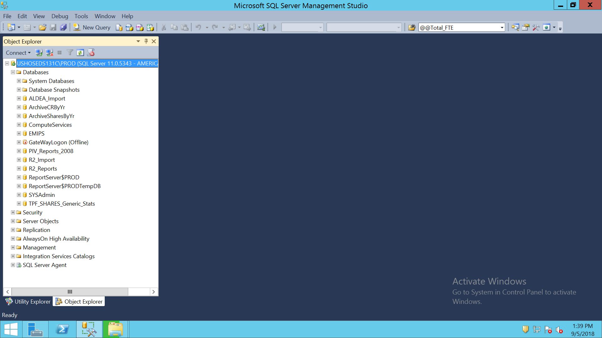

DATA

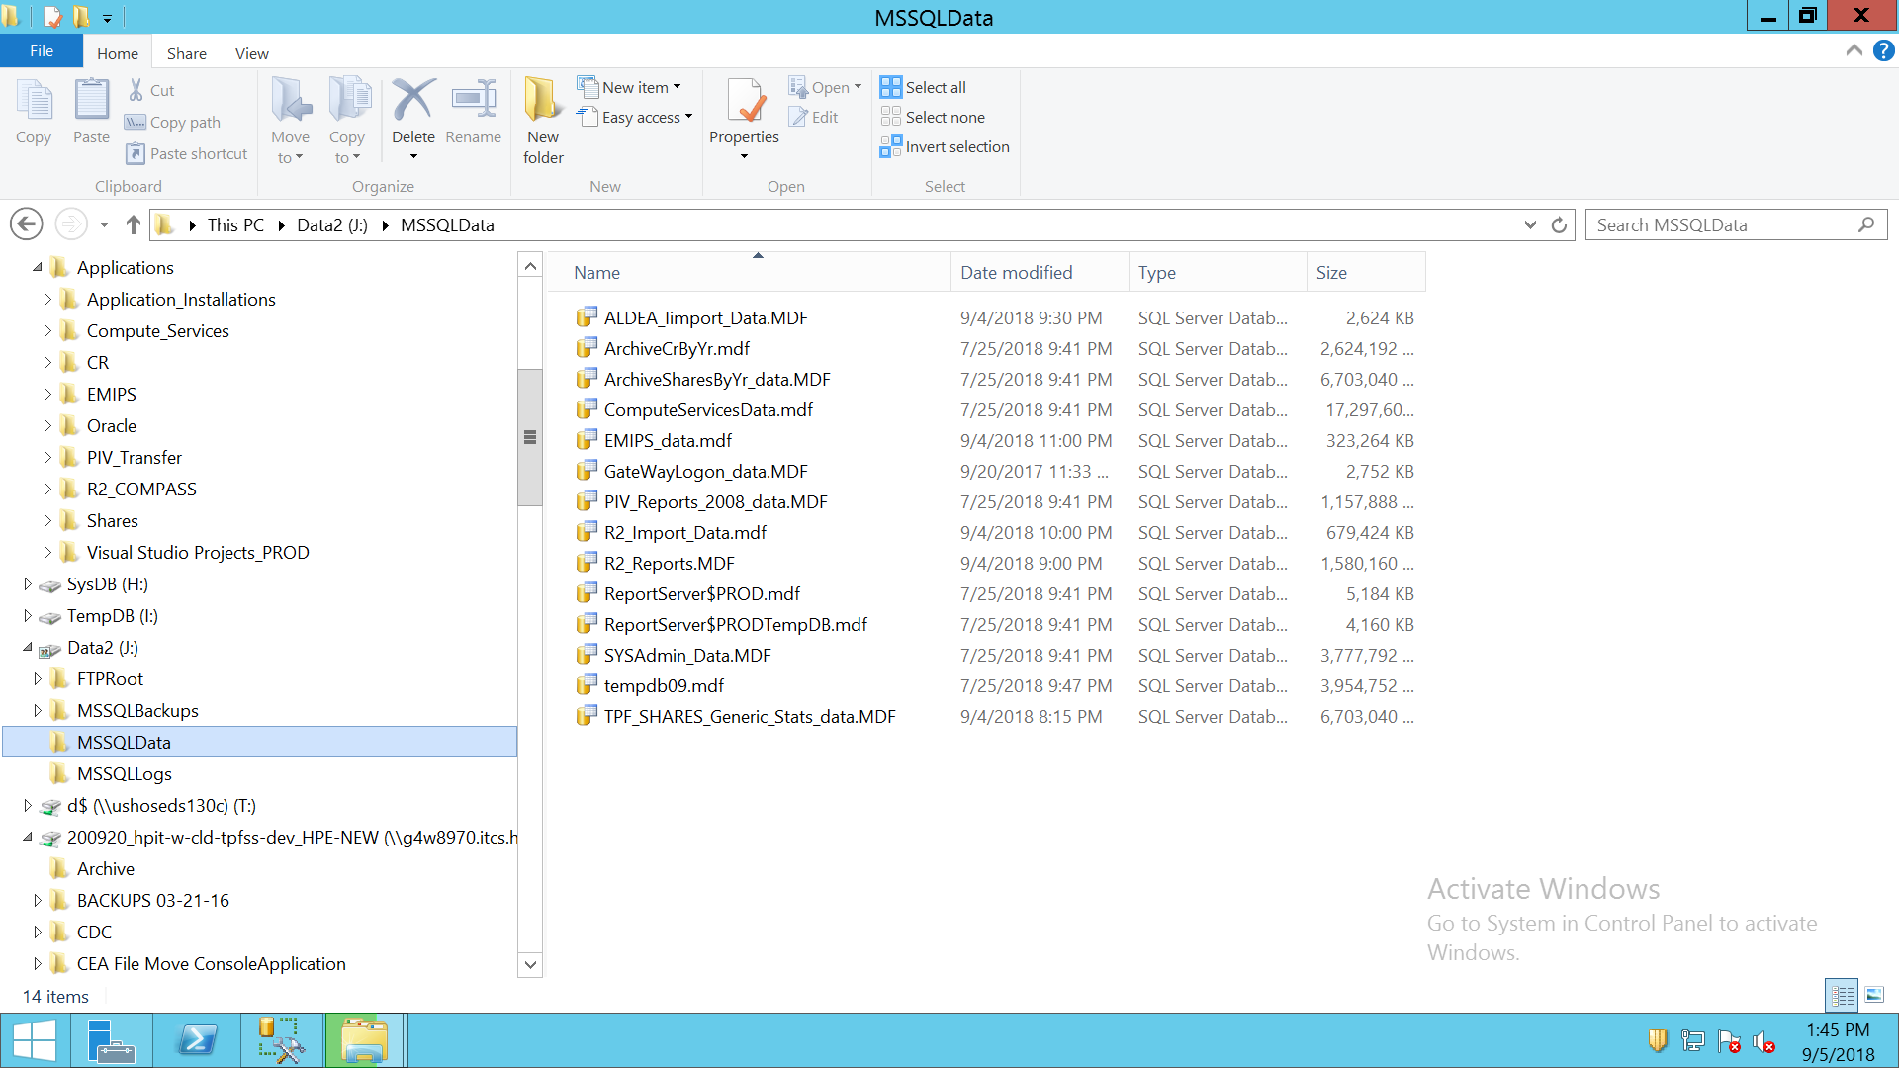

LOGS

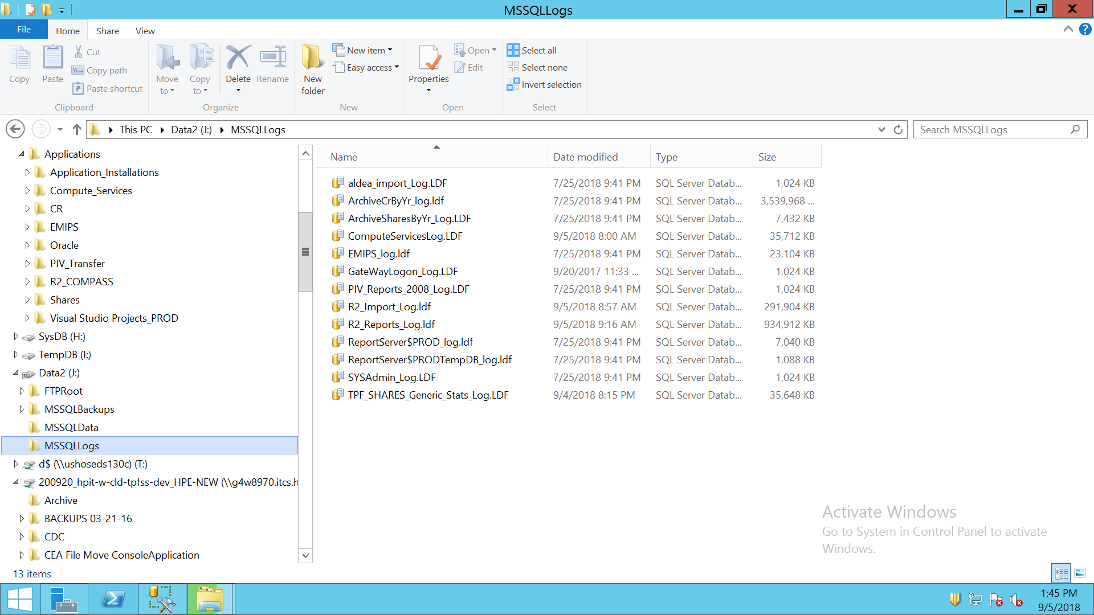

ALDEA

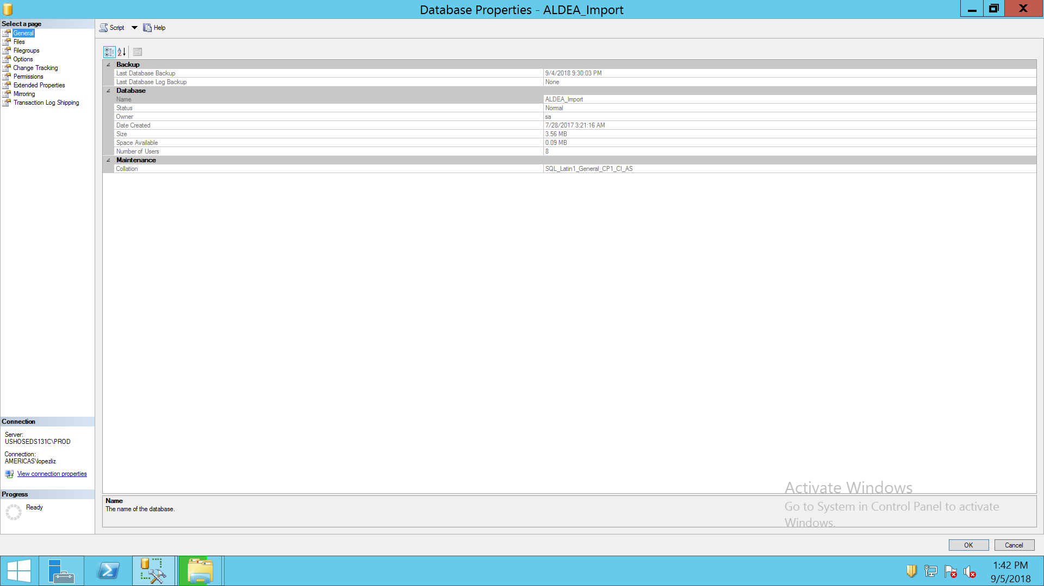

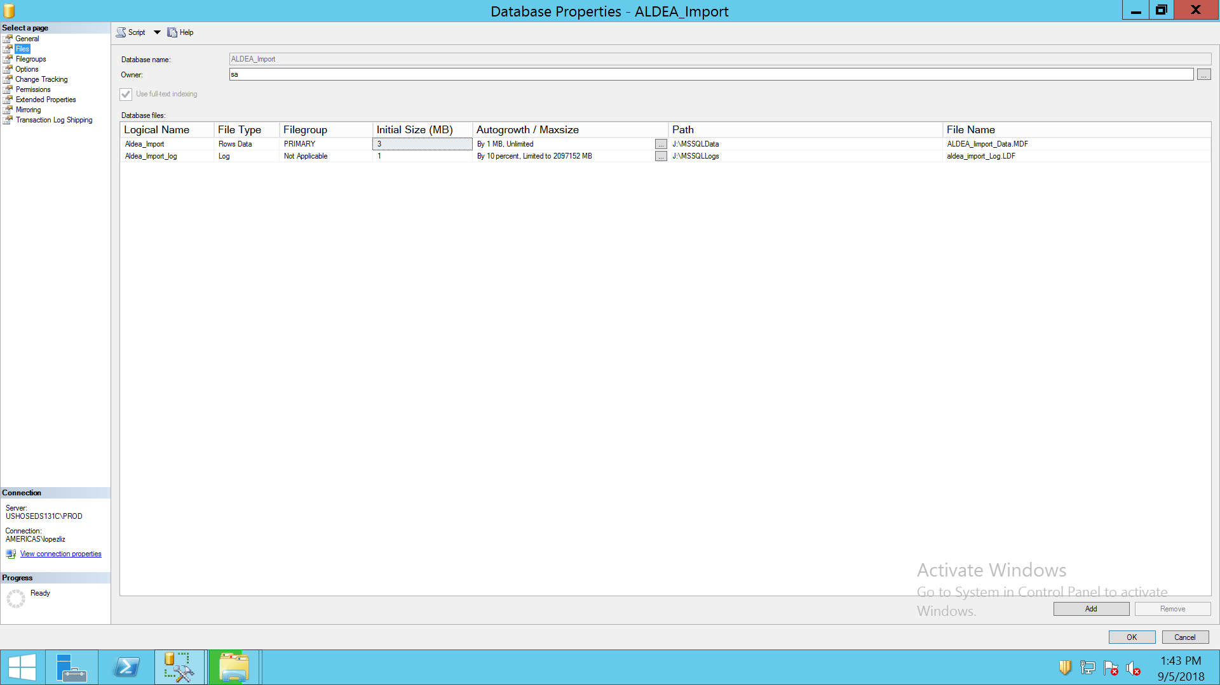

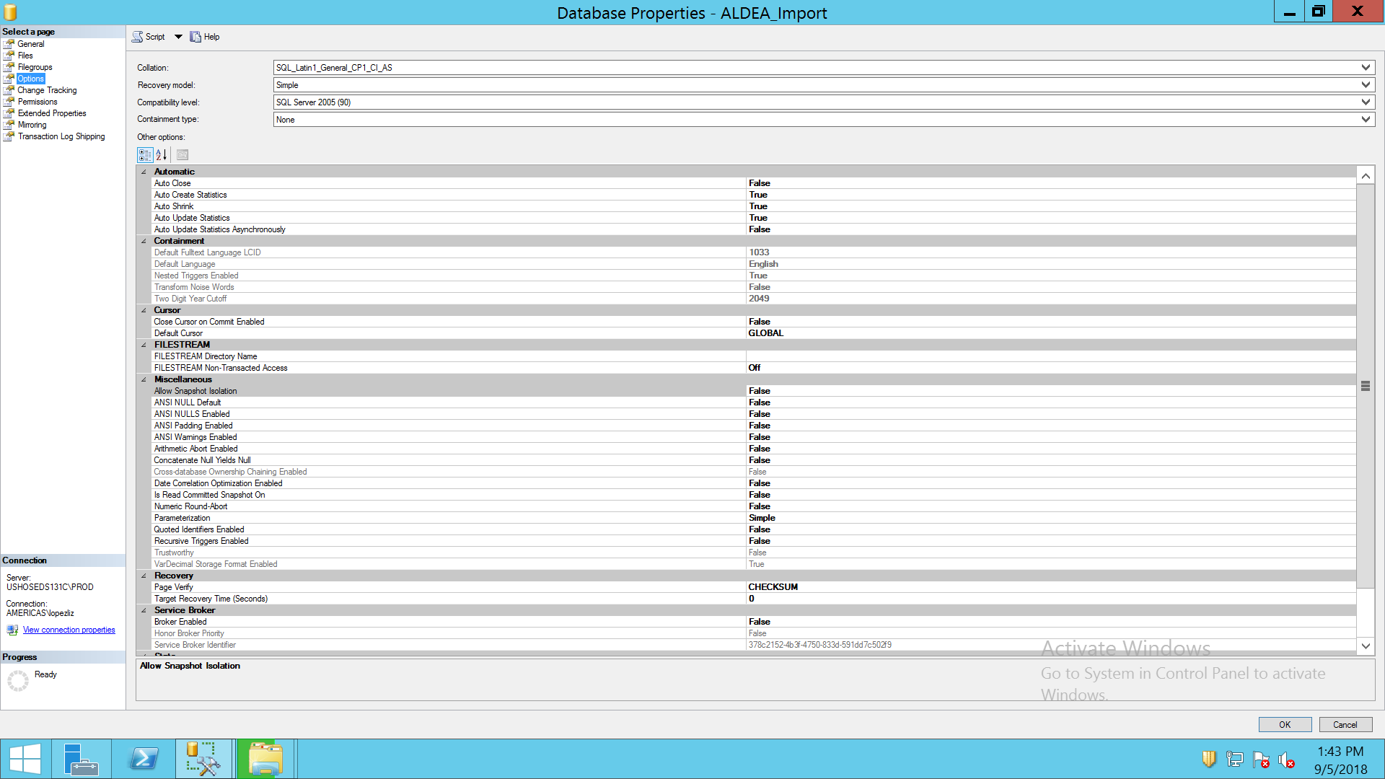

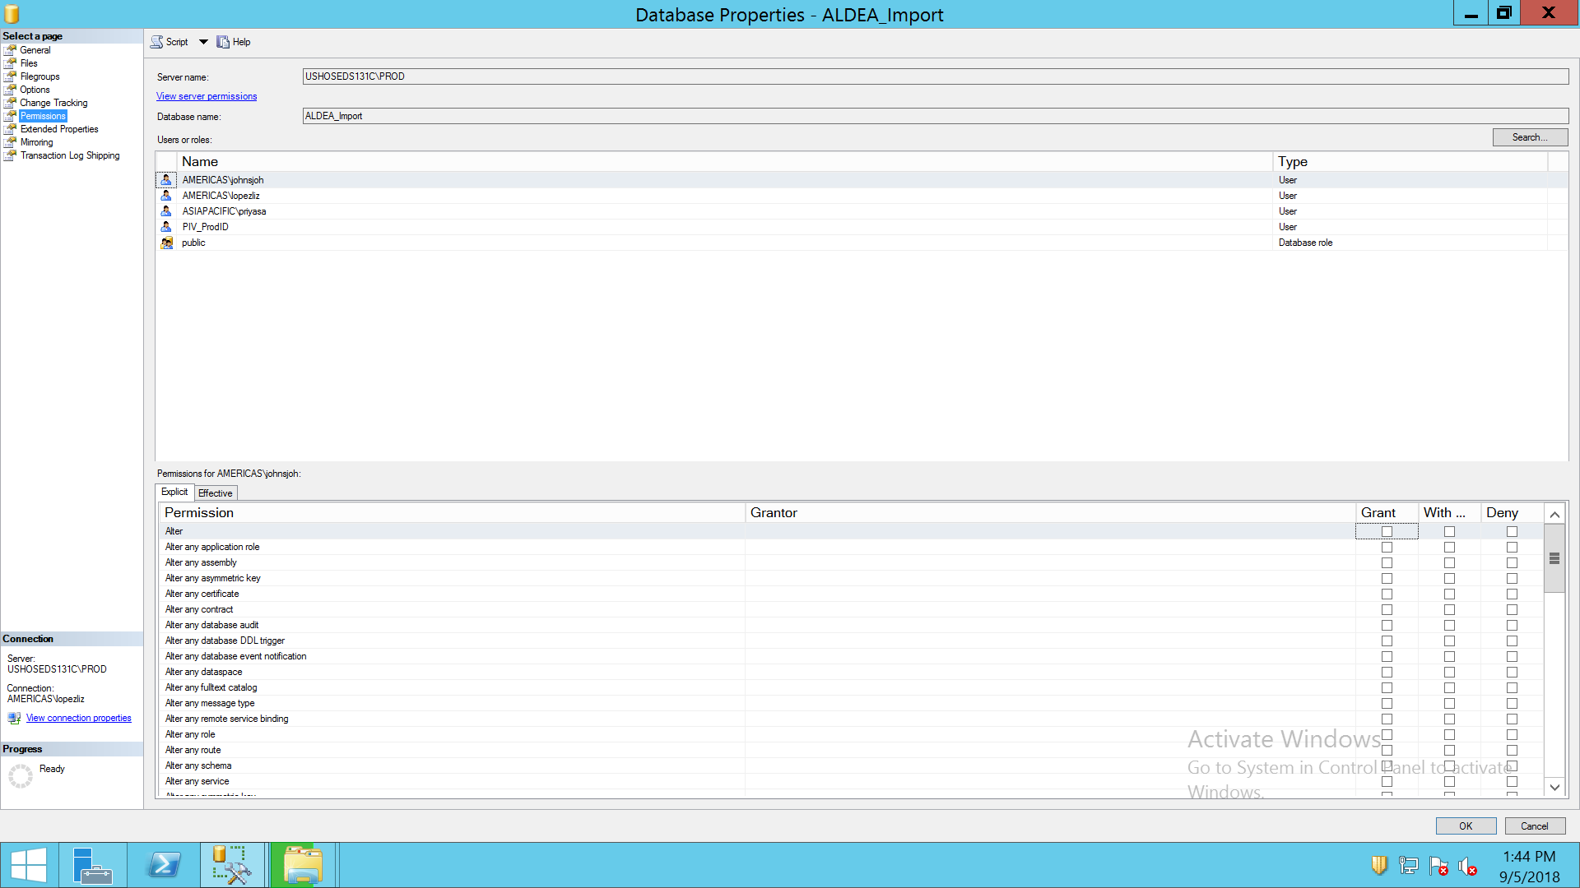

ARCHIVECRBYYEAR

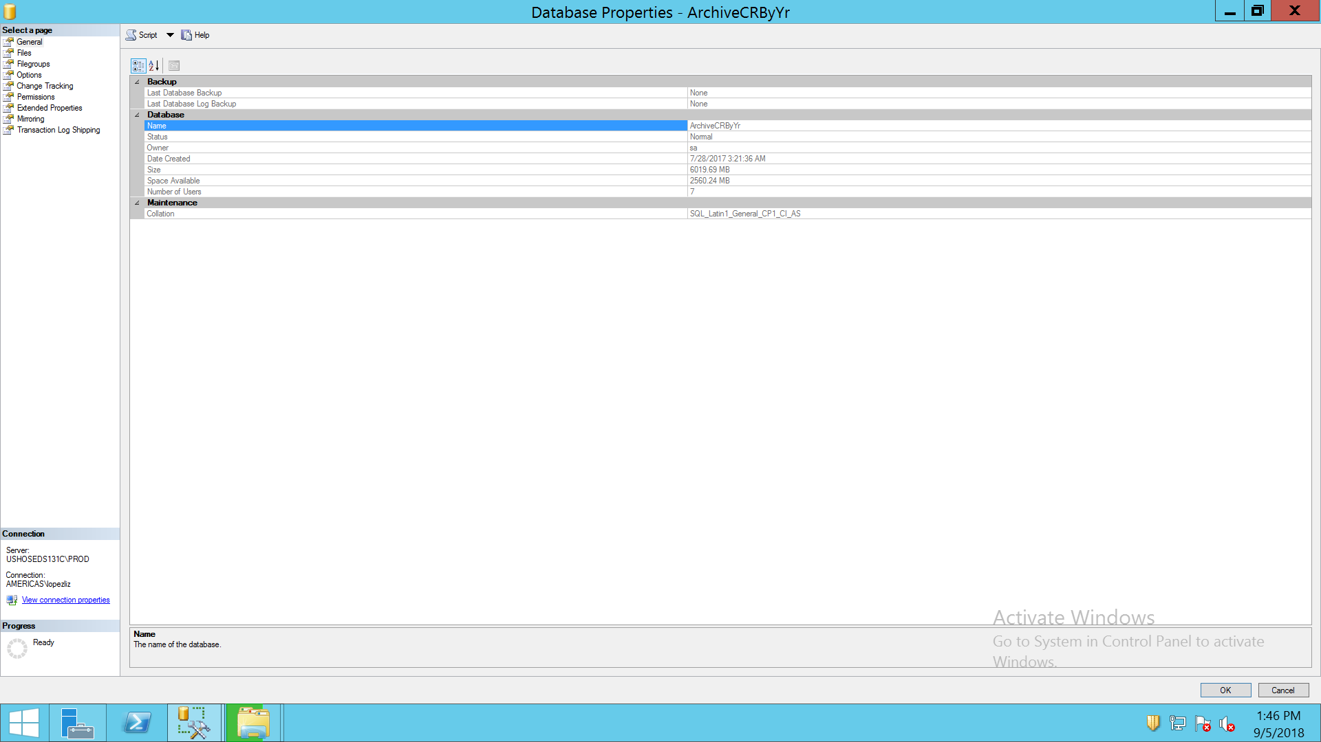

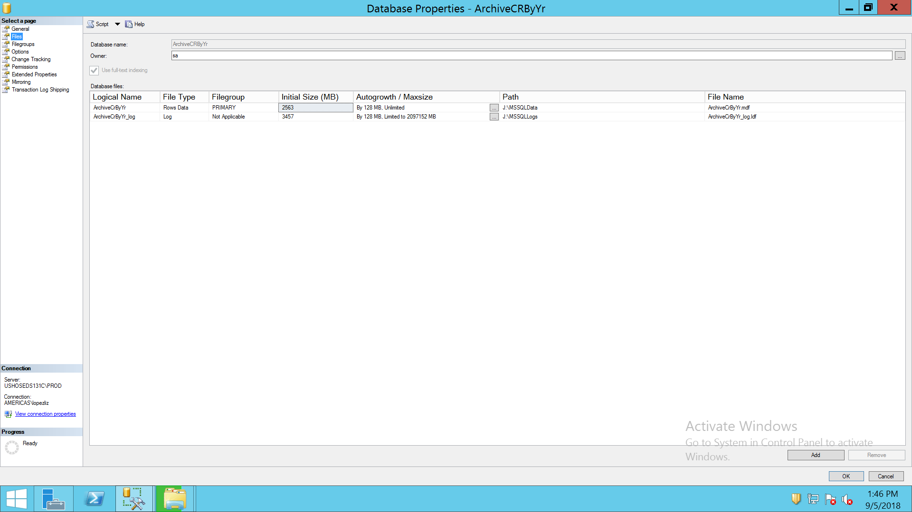

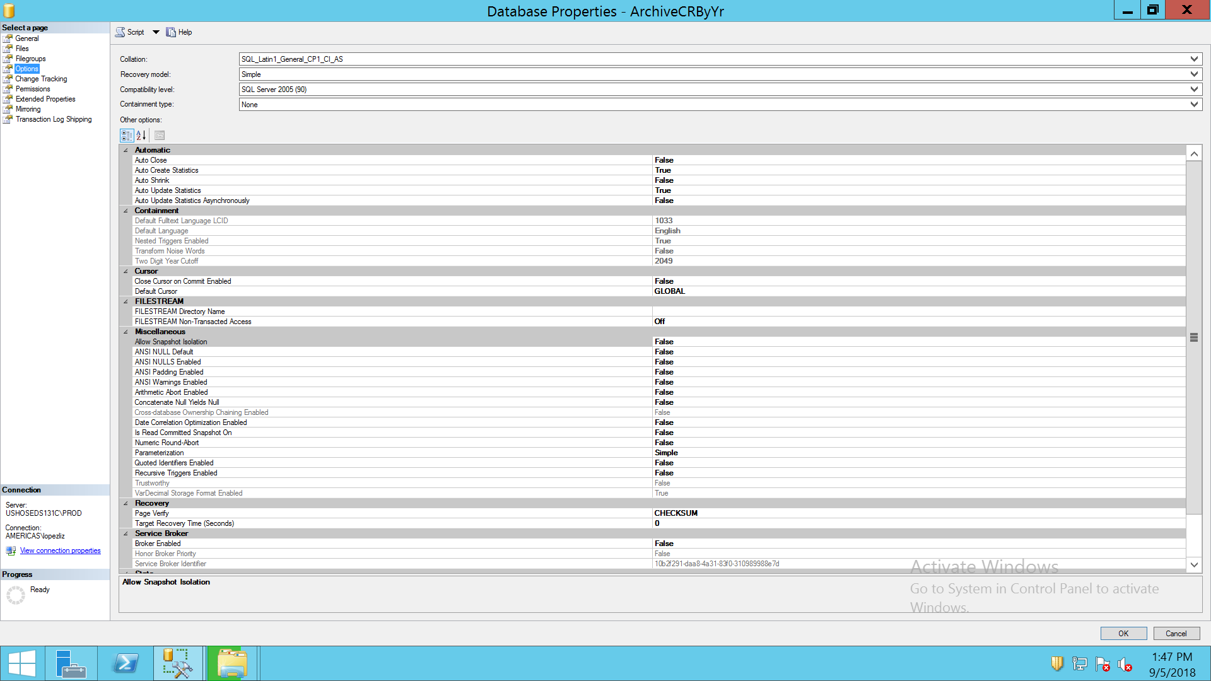

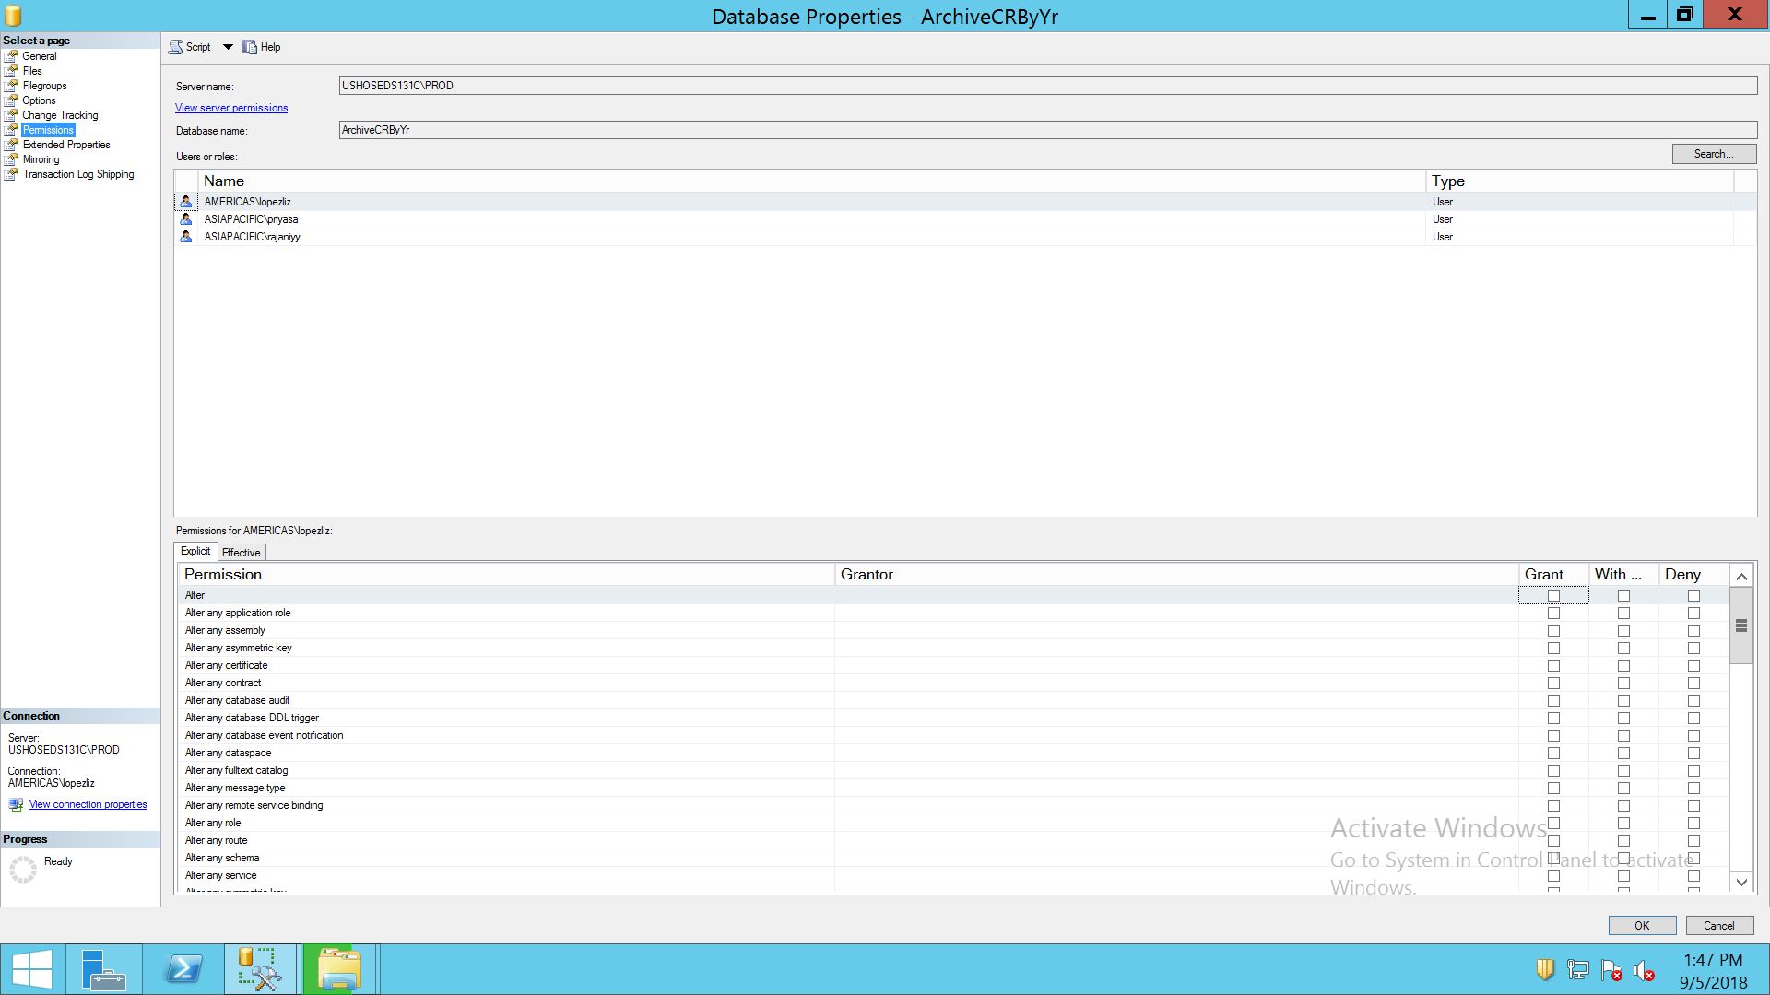

ARCHIVE SHARES BY YR

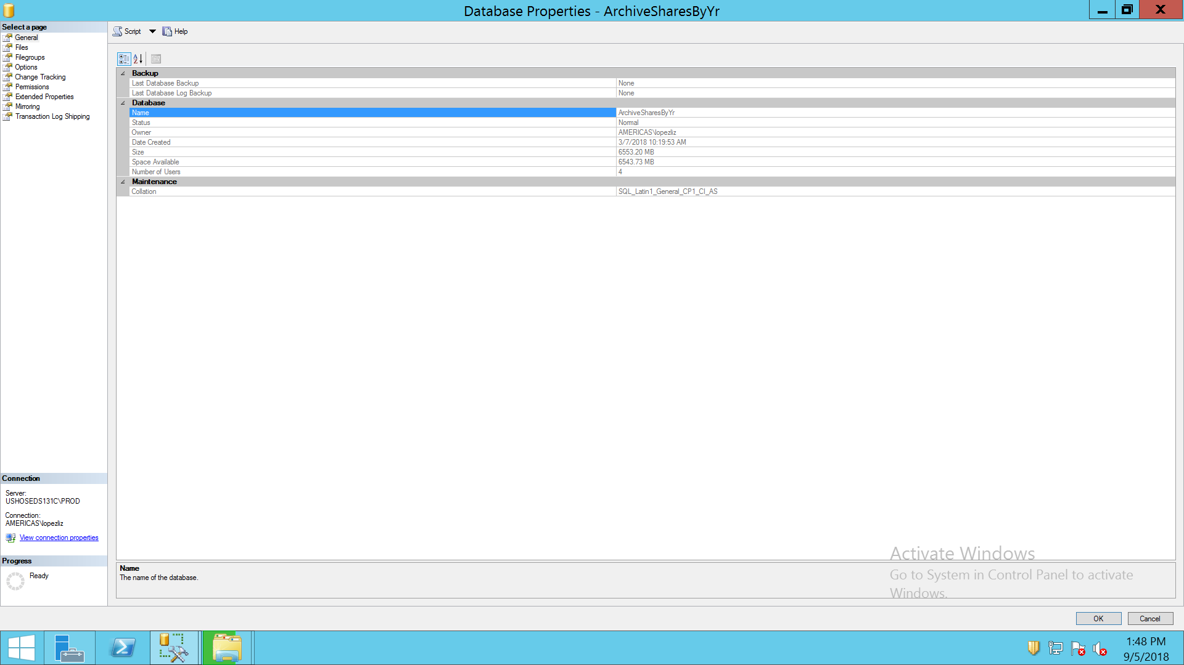

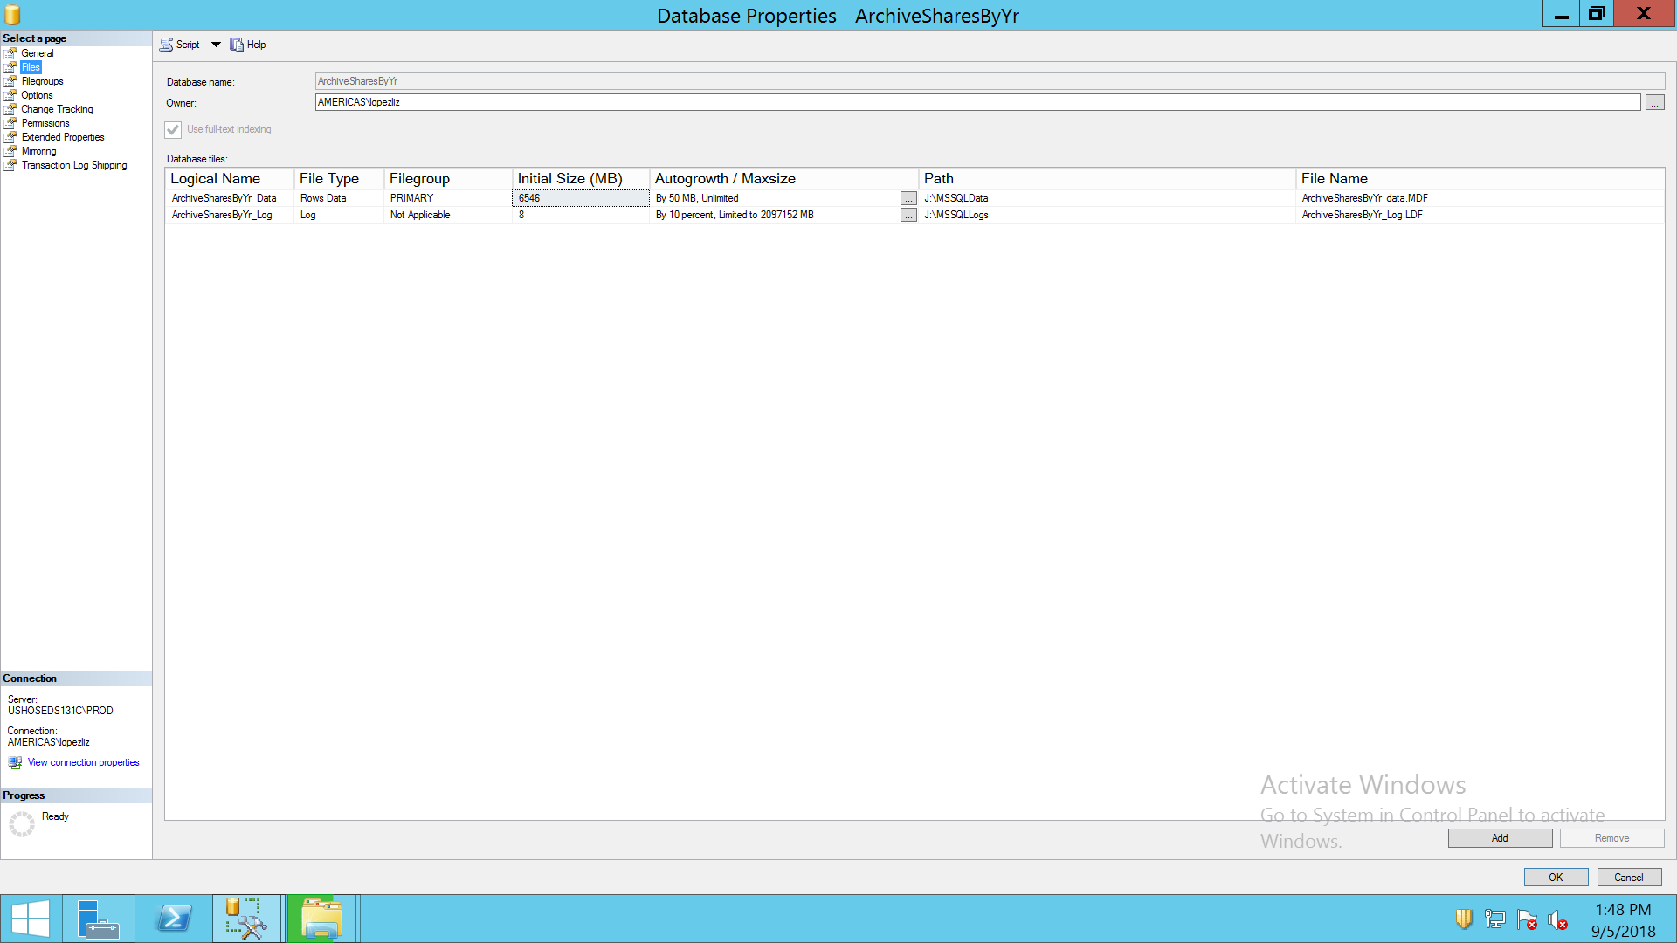

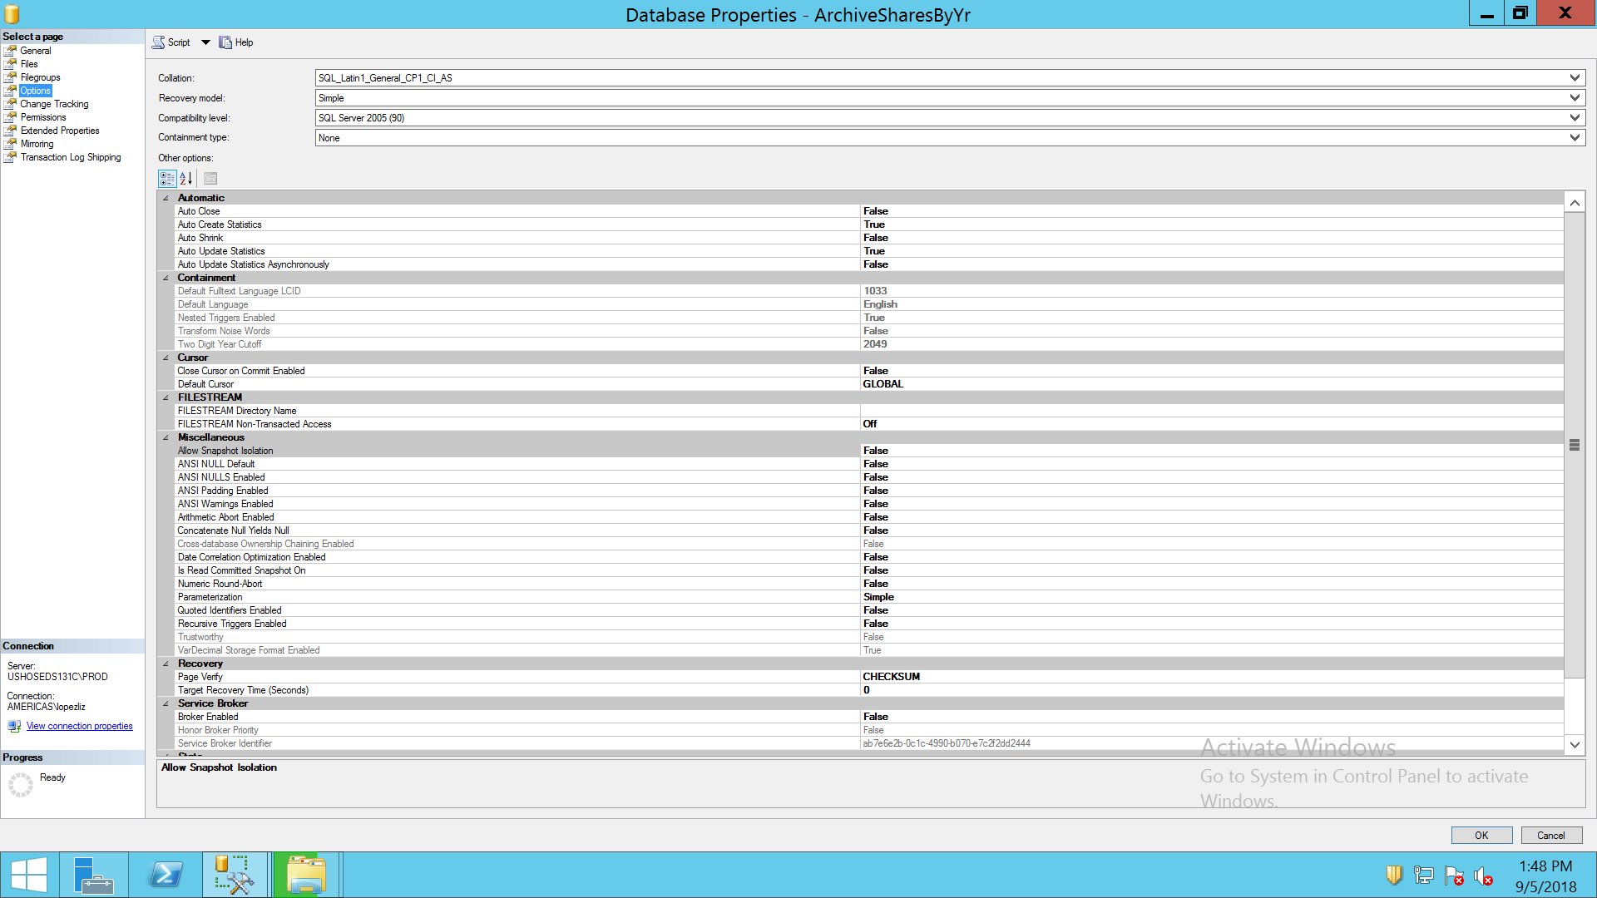

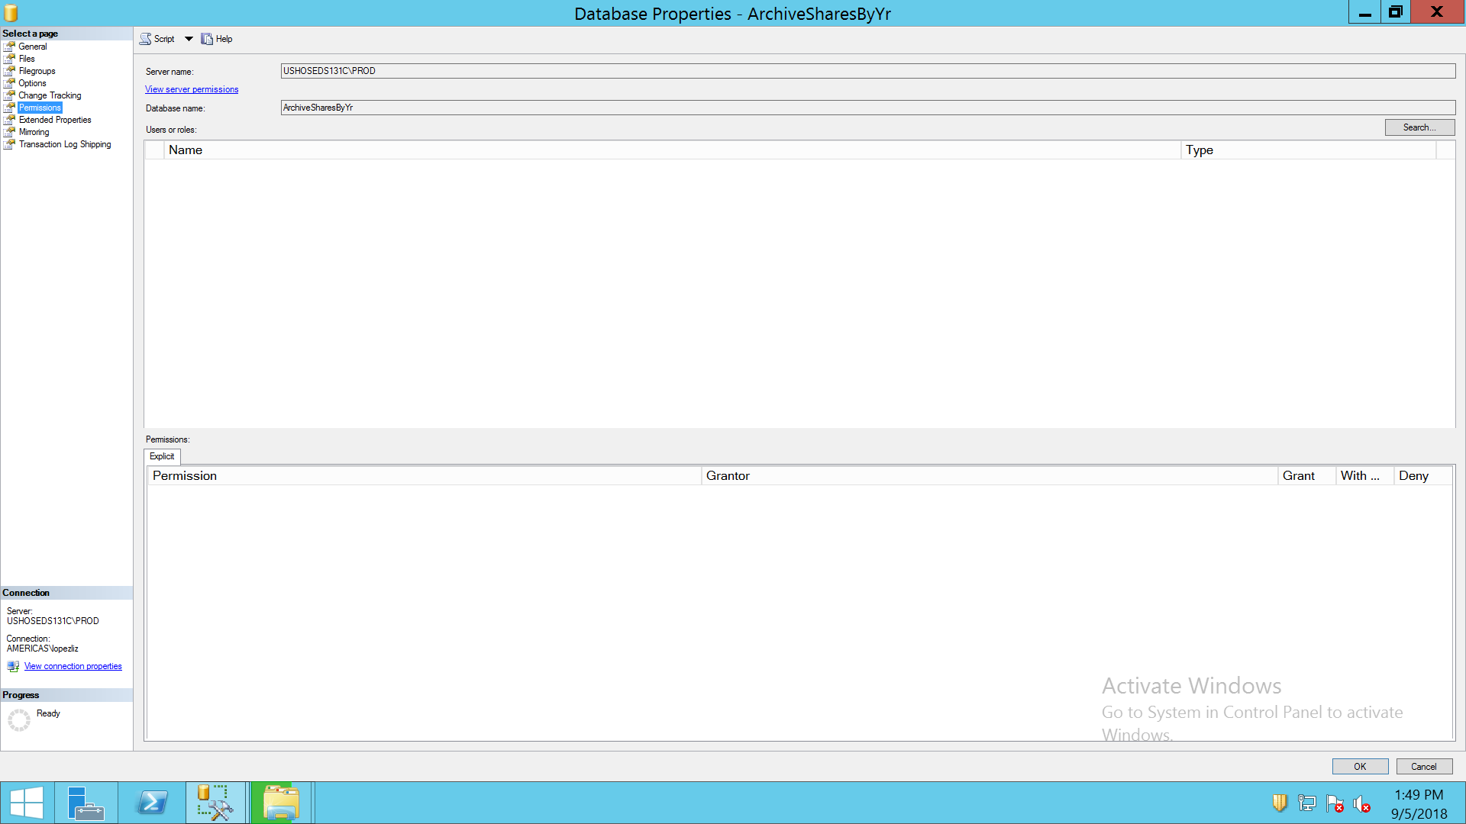

COMPUTESERVICES

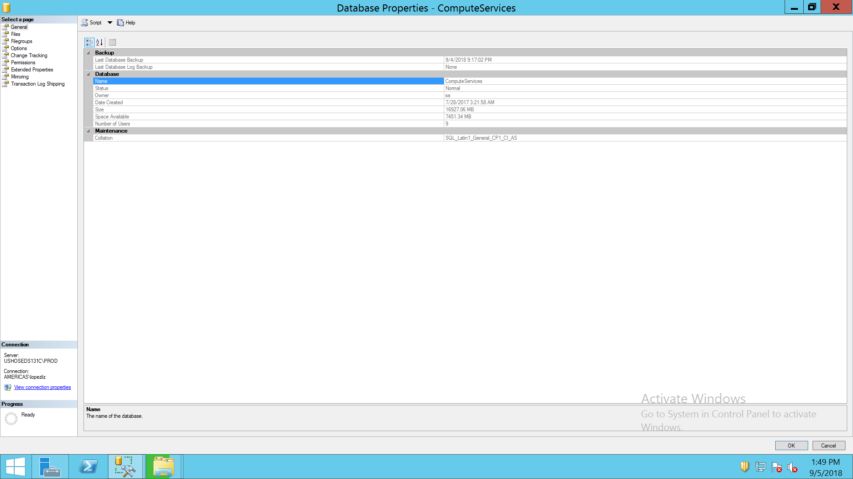

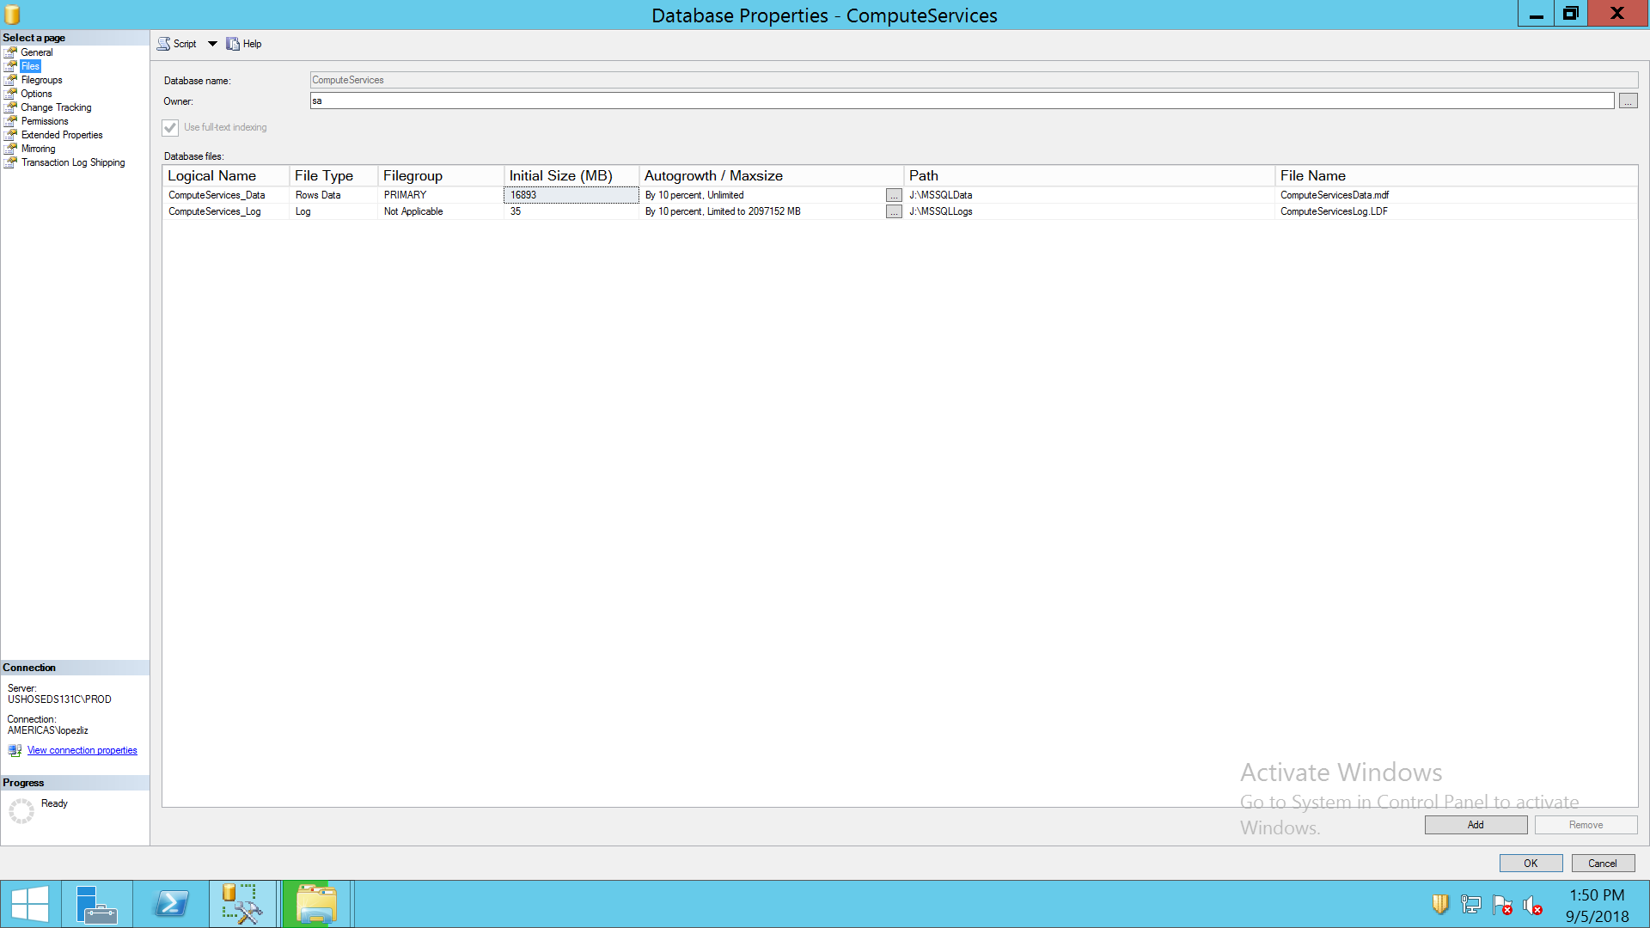

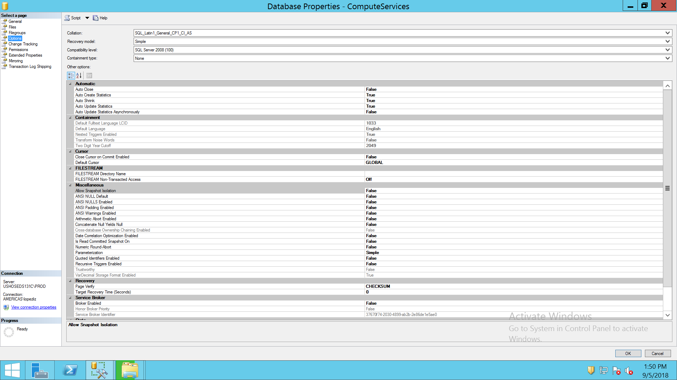

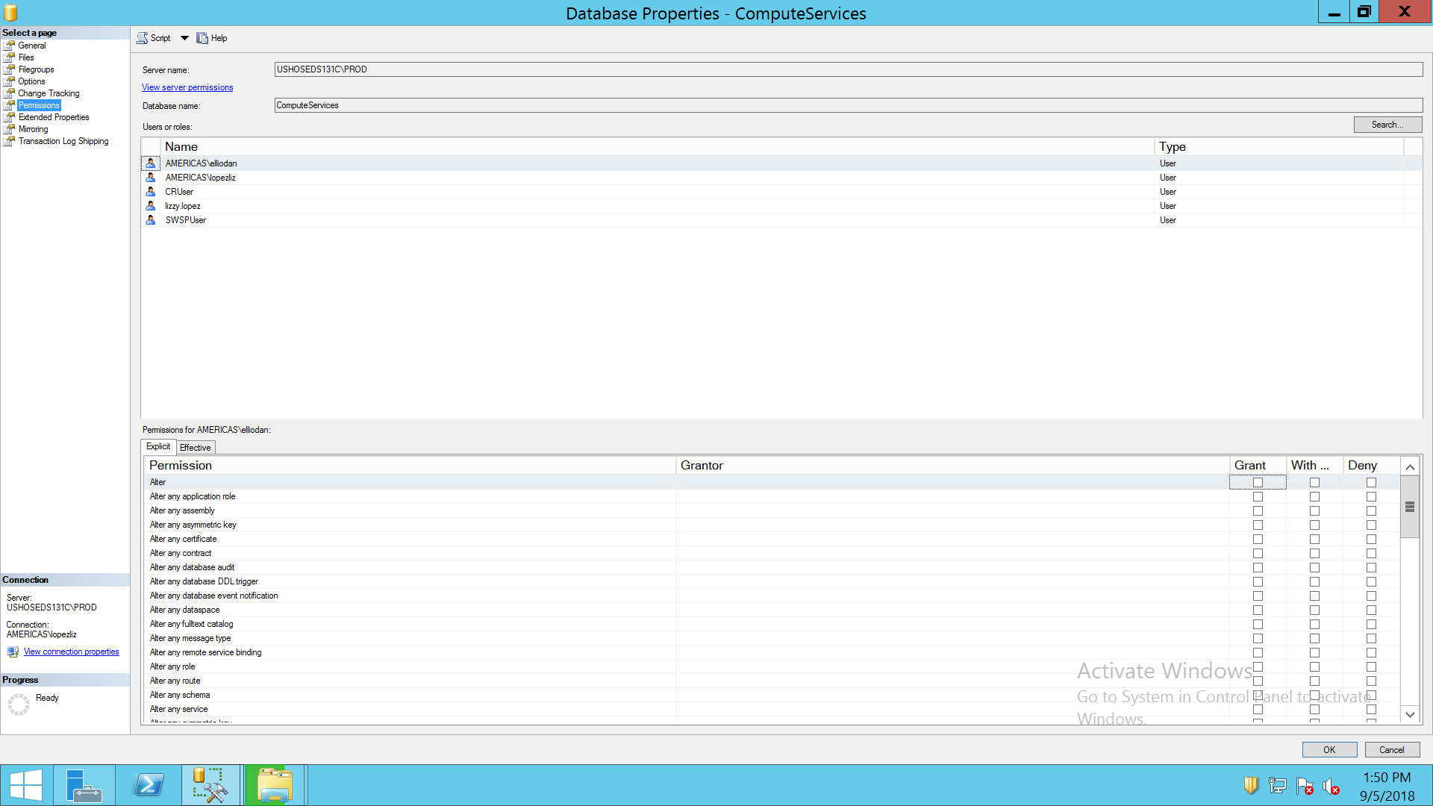

EMIPS

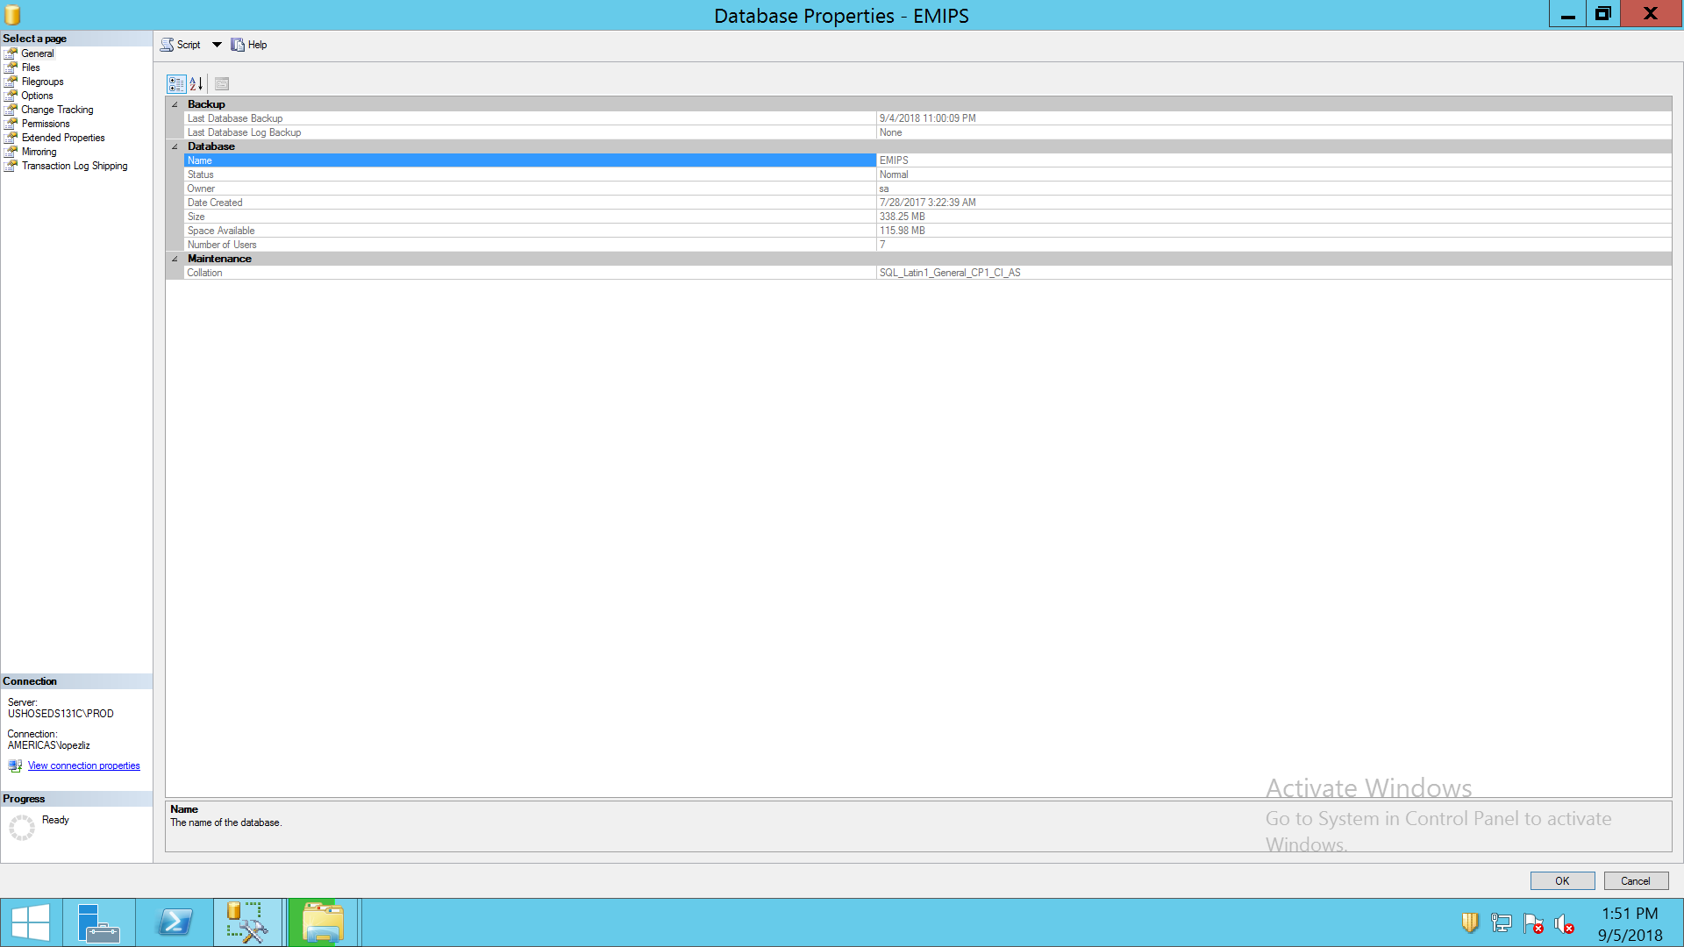

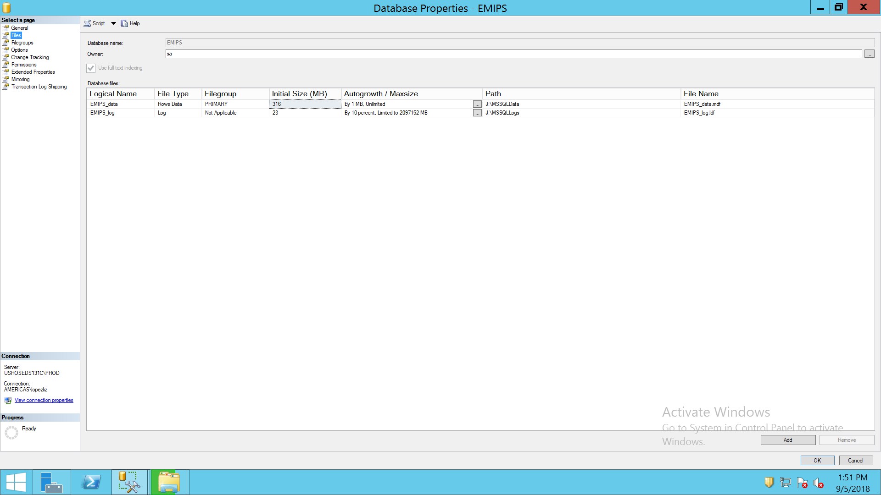

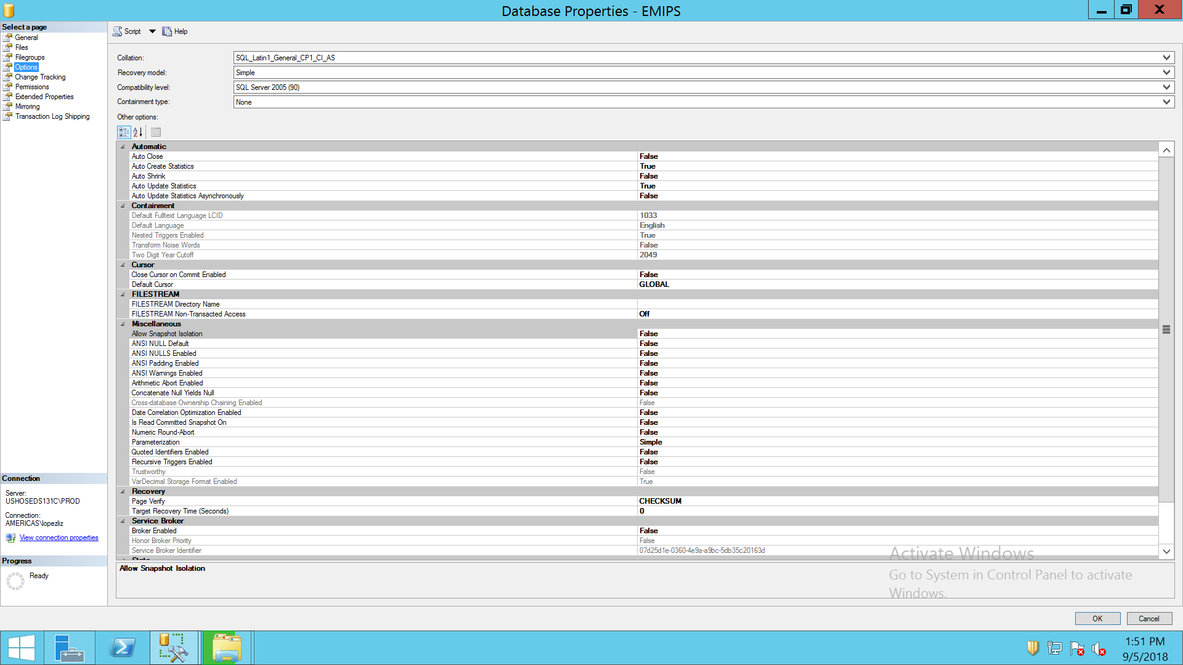

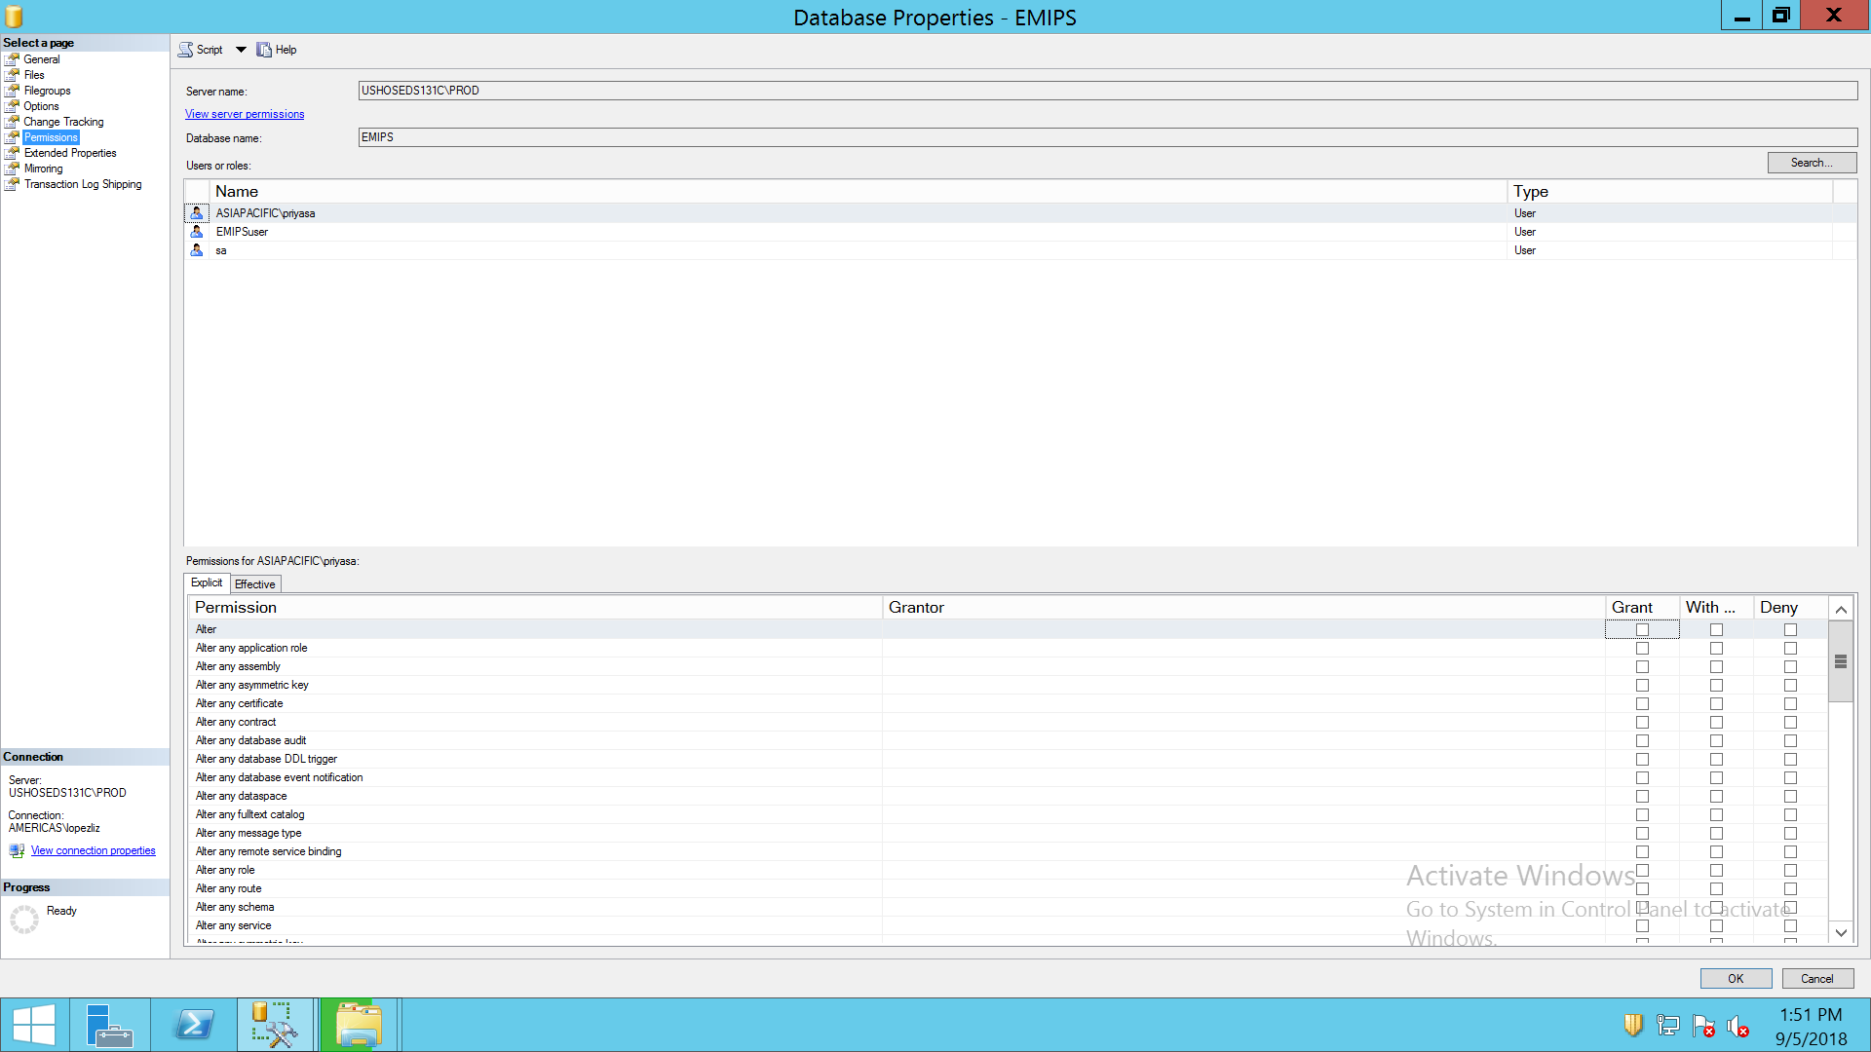

PIV REPORTS 2008

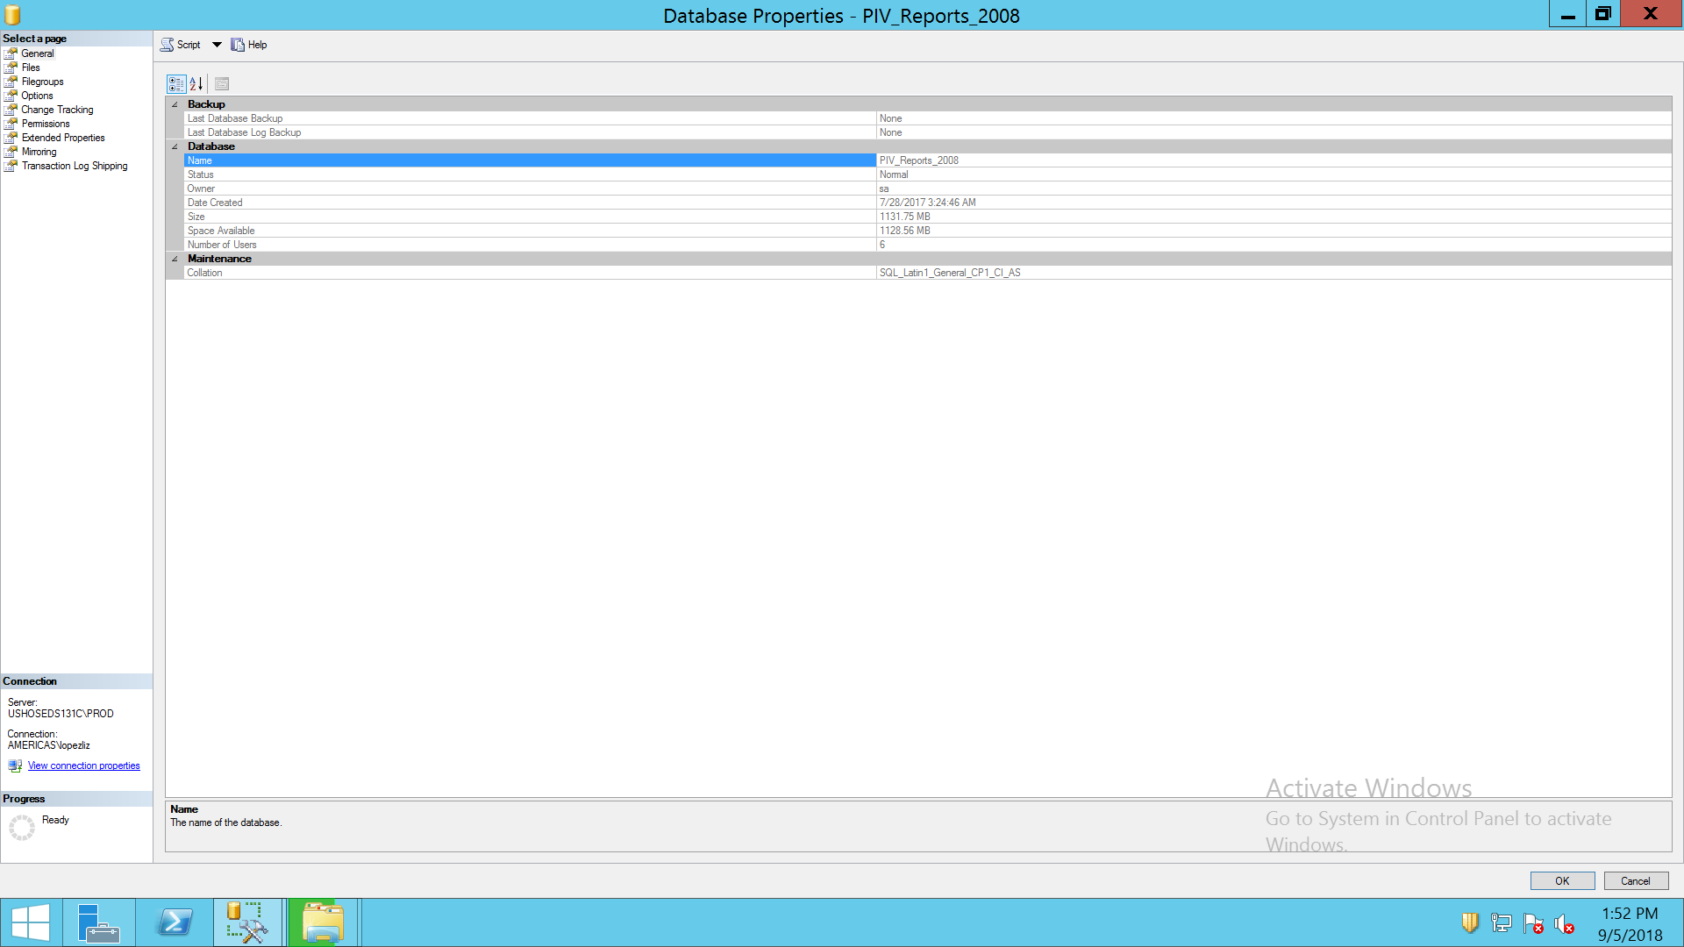

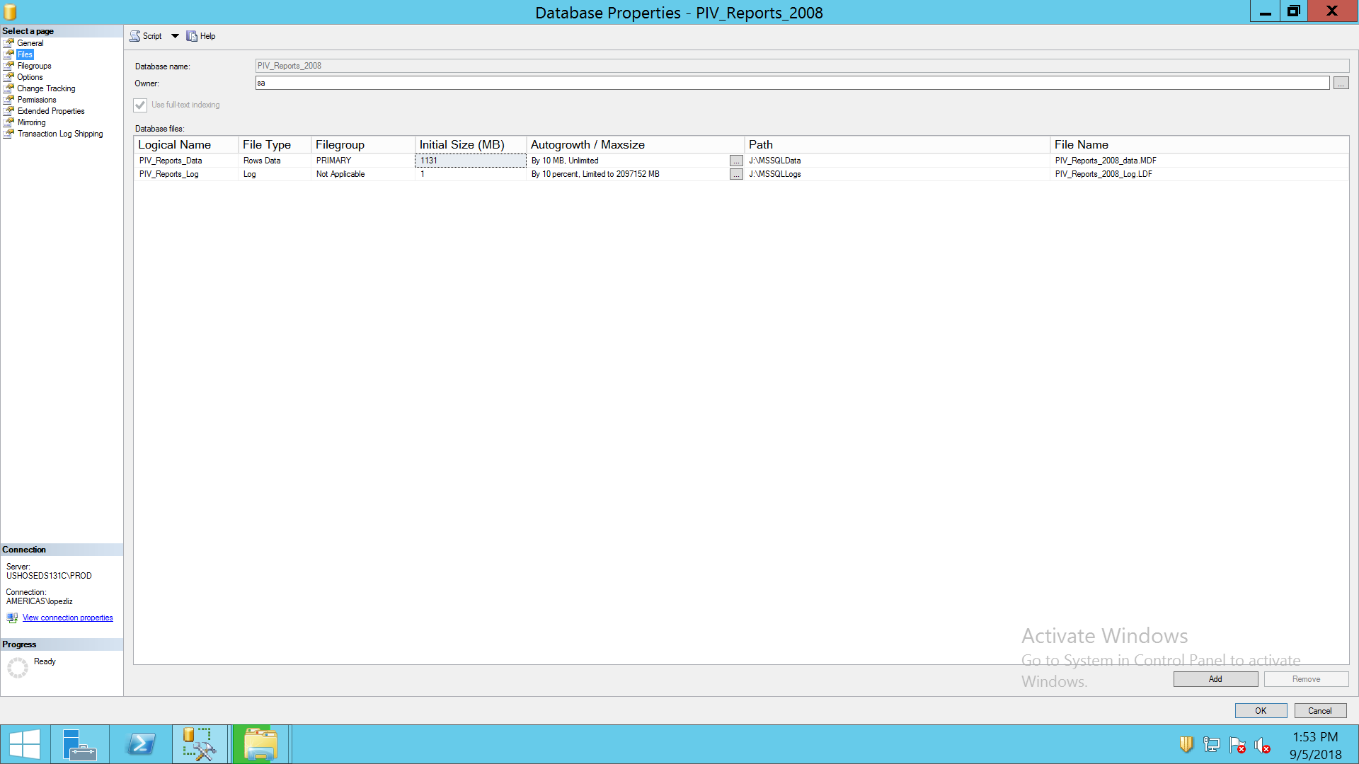

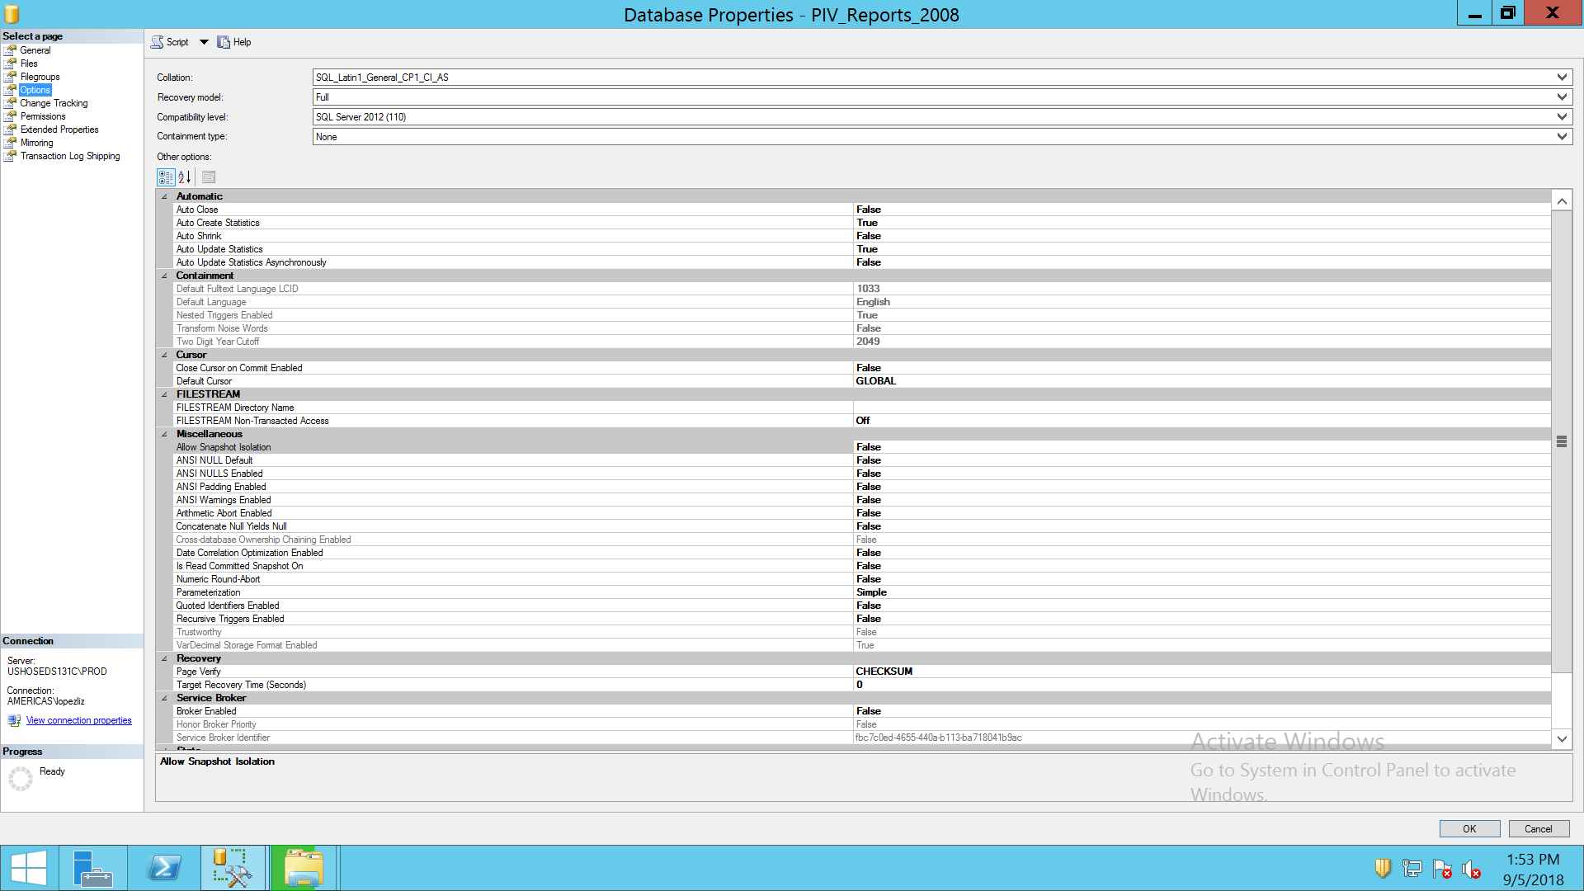

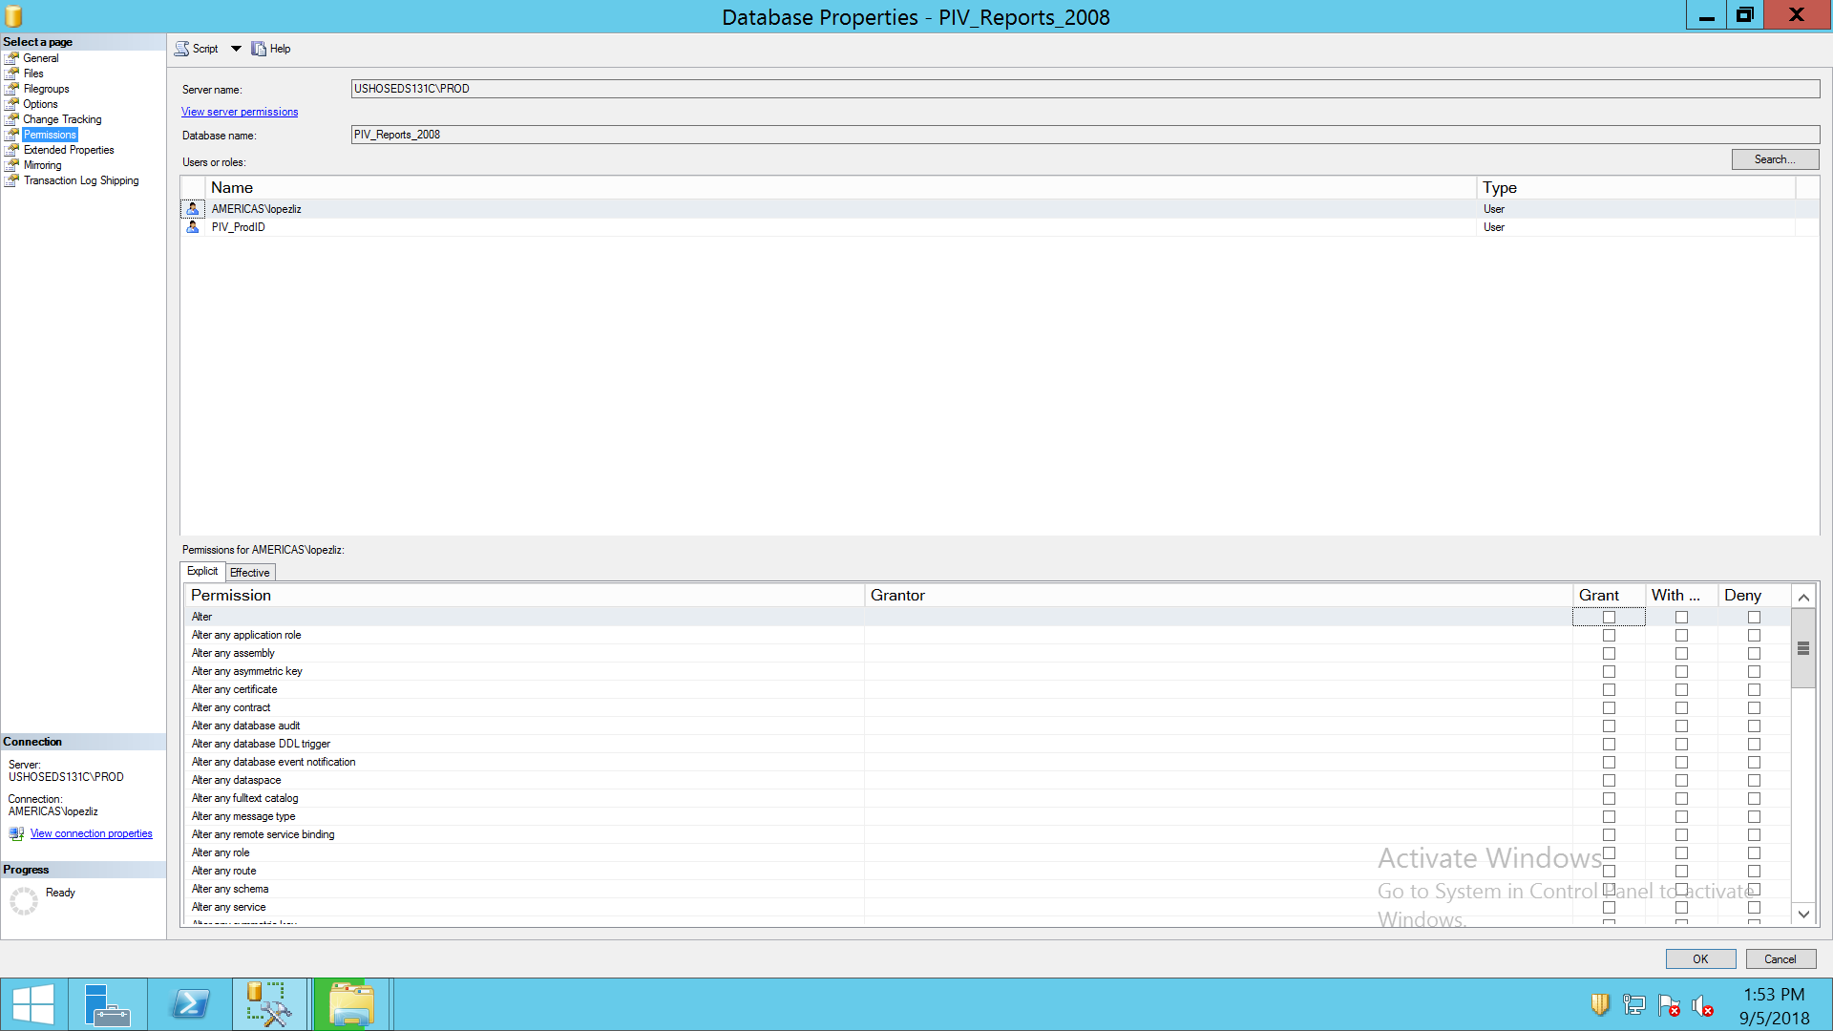

R2_IMPORT

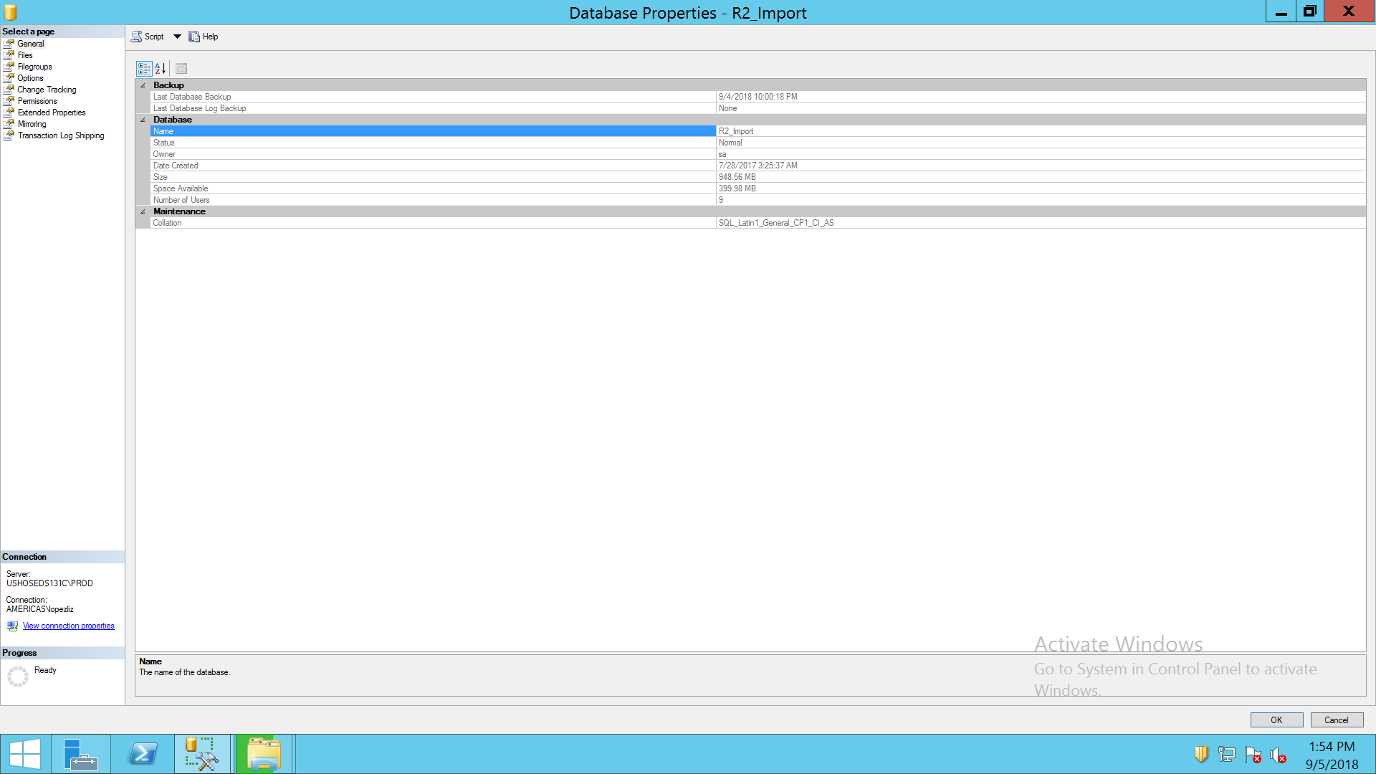

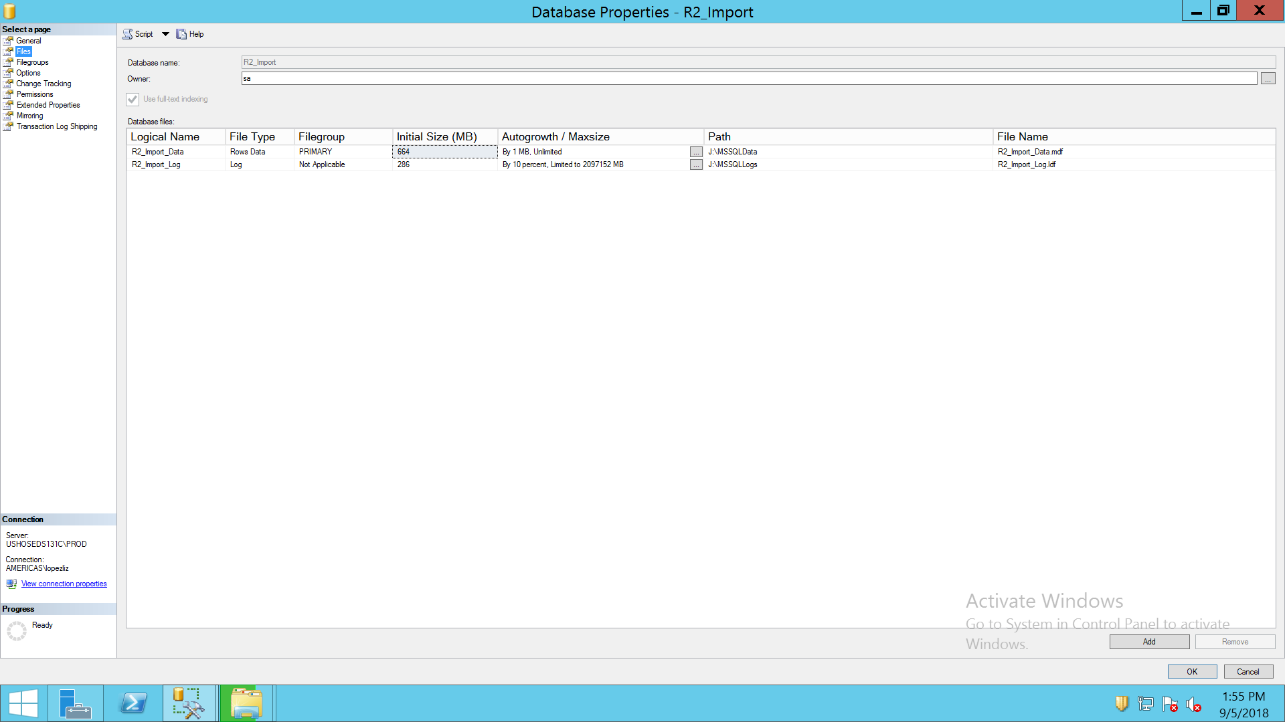

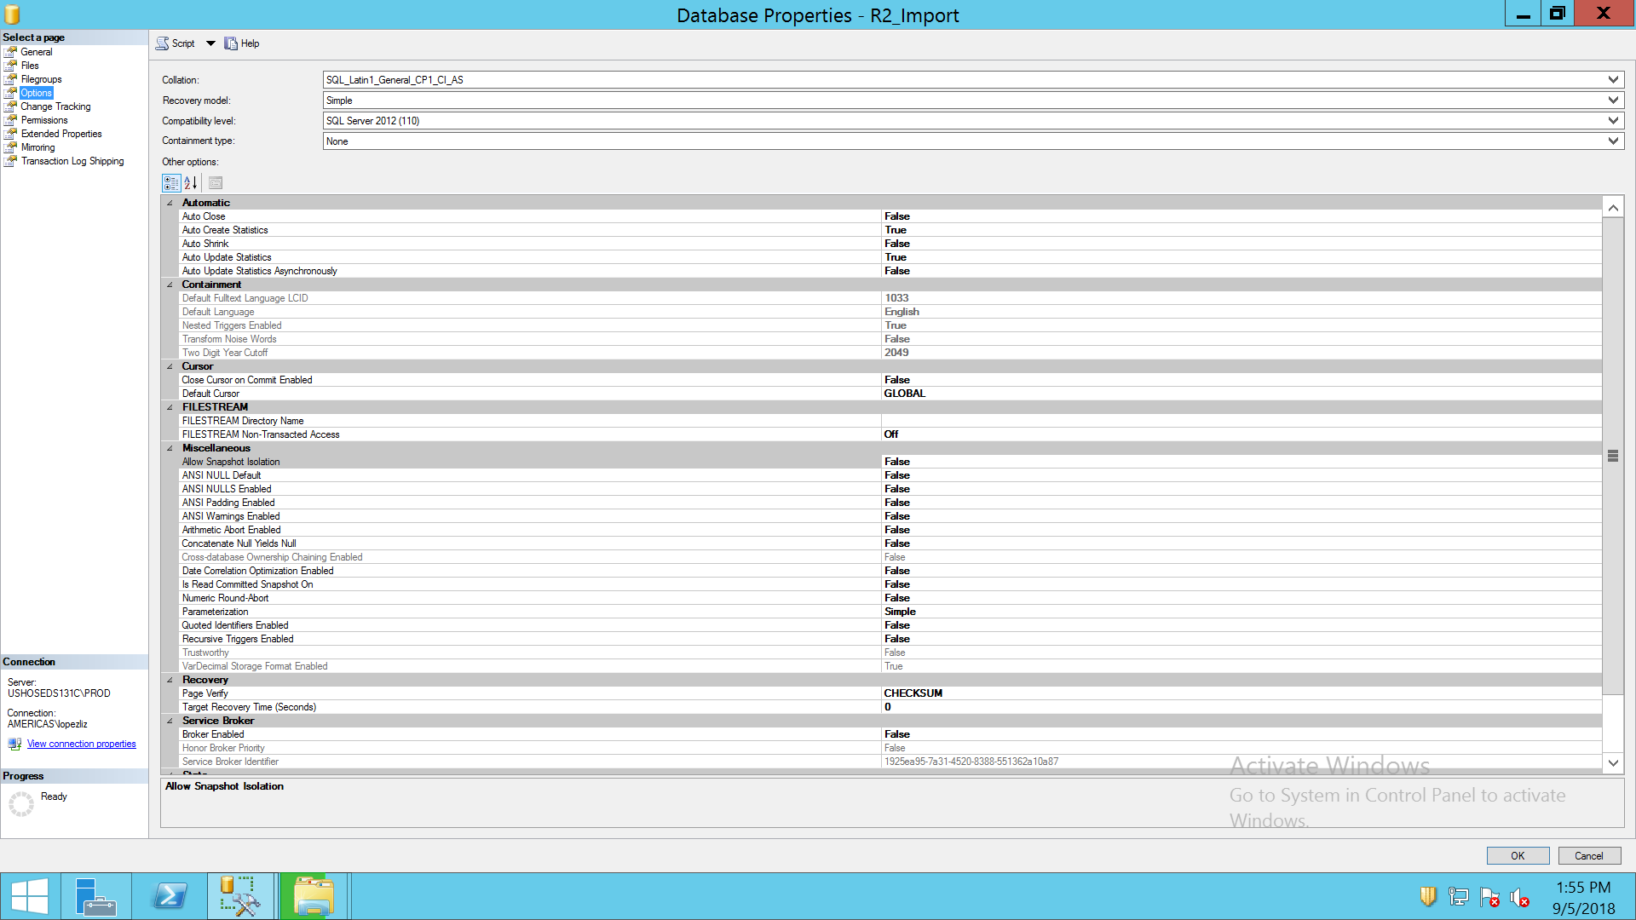

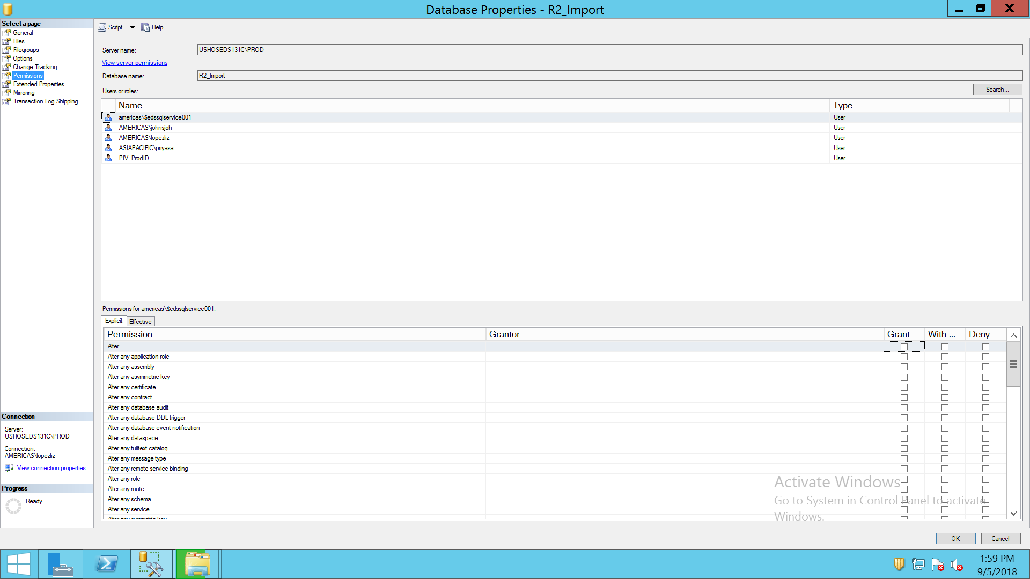

R2_REPORTS

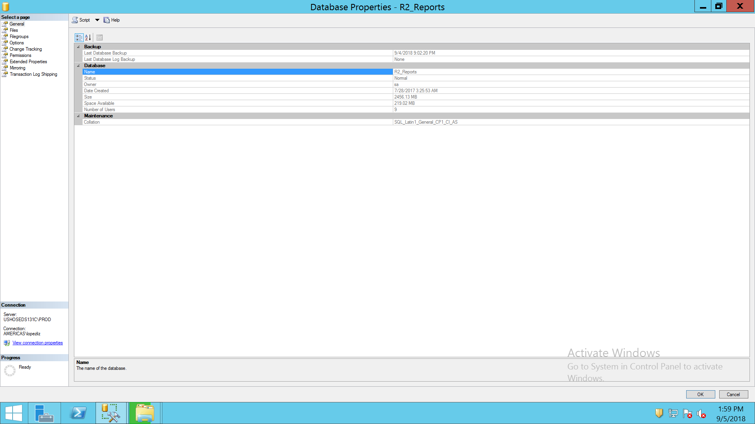

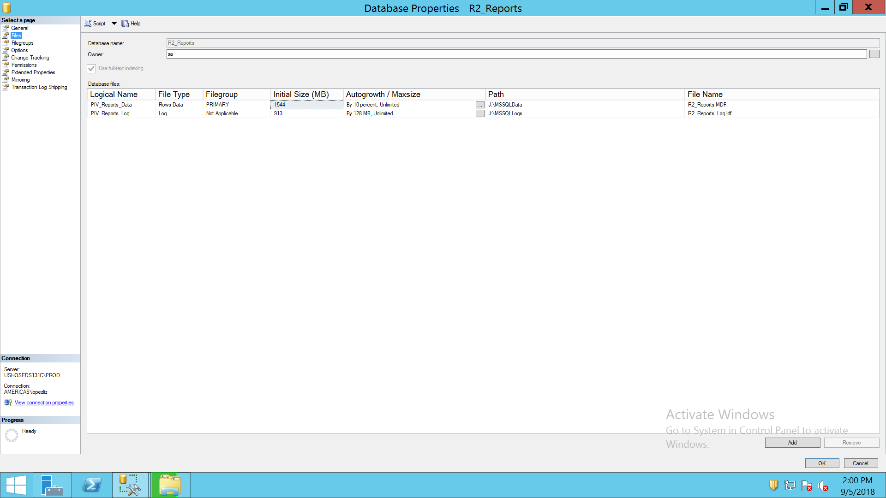

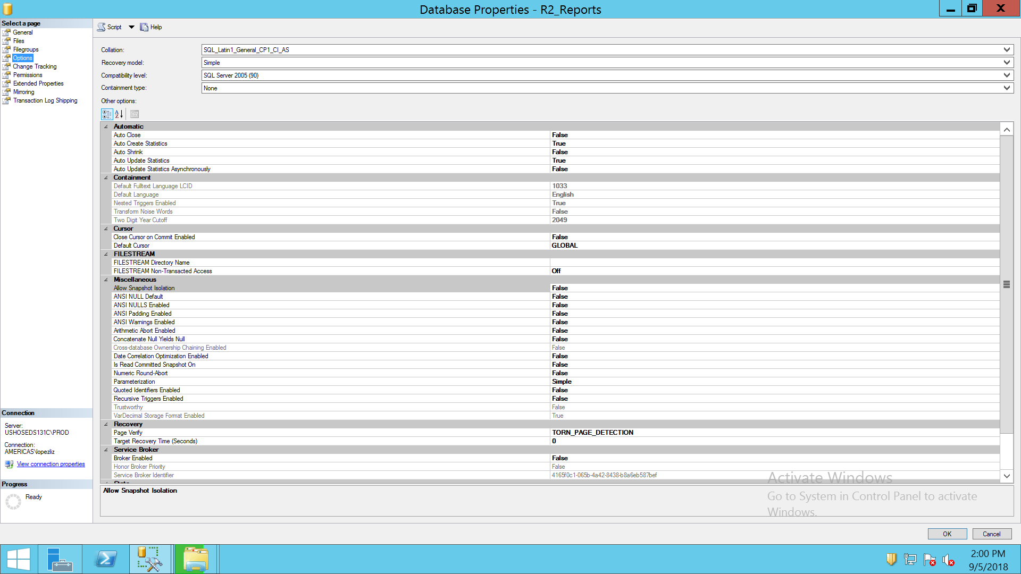

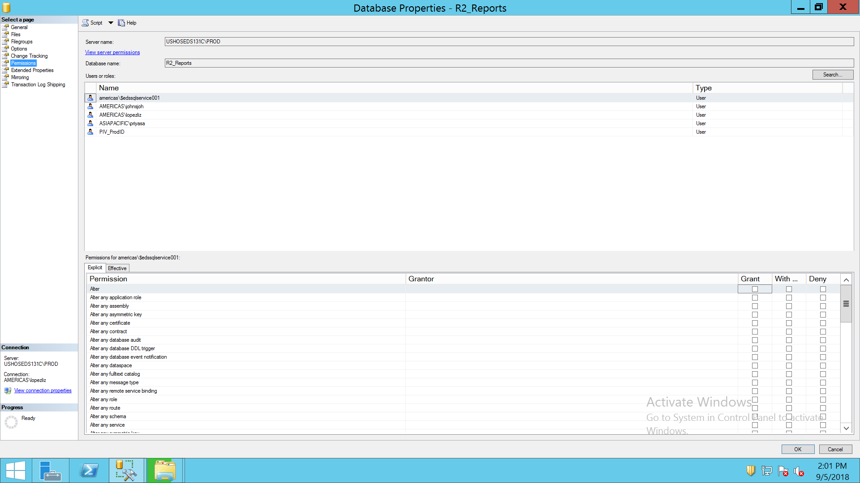

TPF_SHARES_GENERIC_STATS

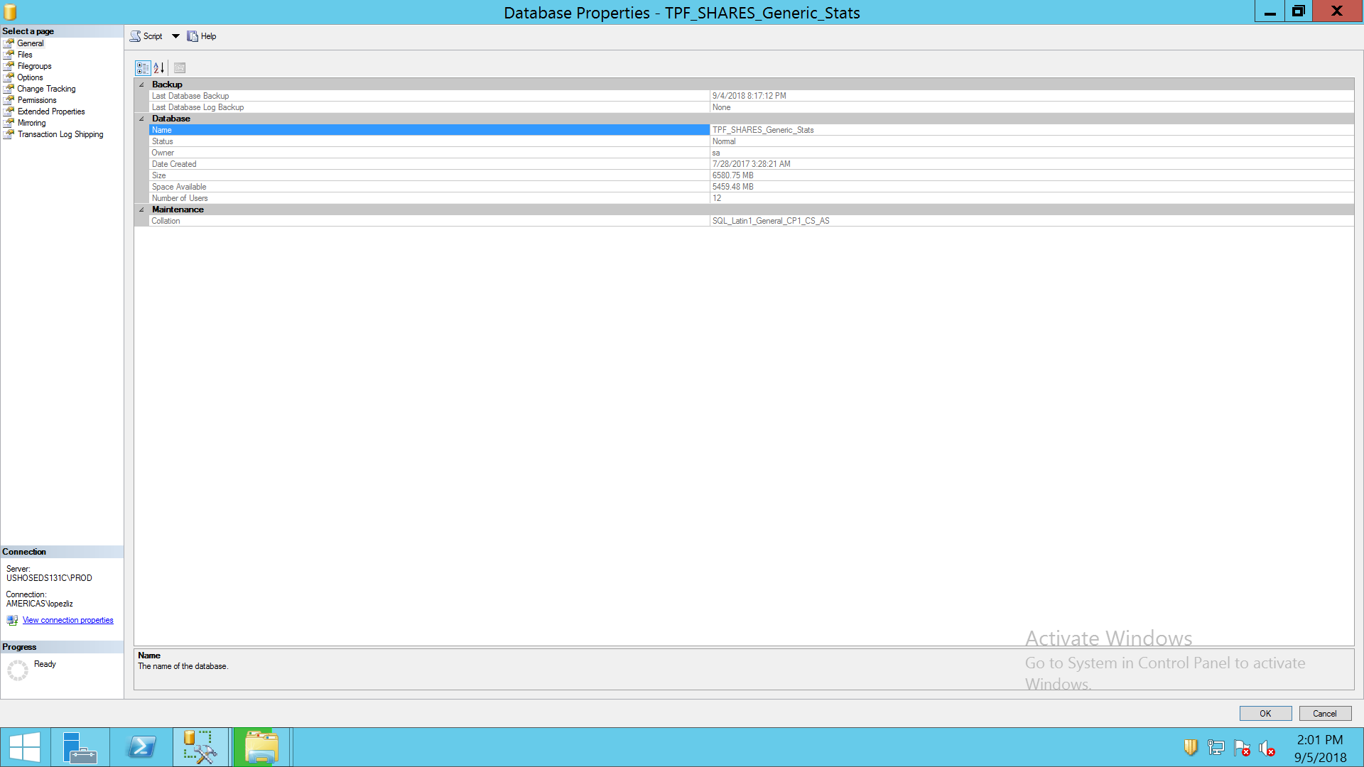

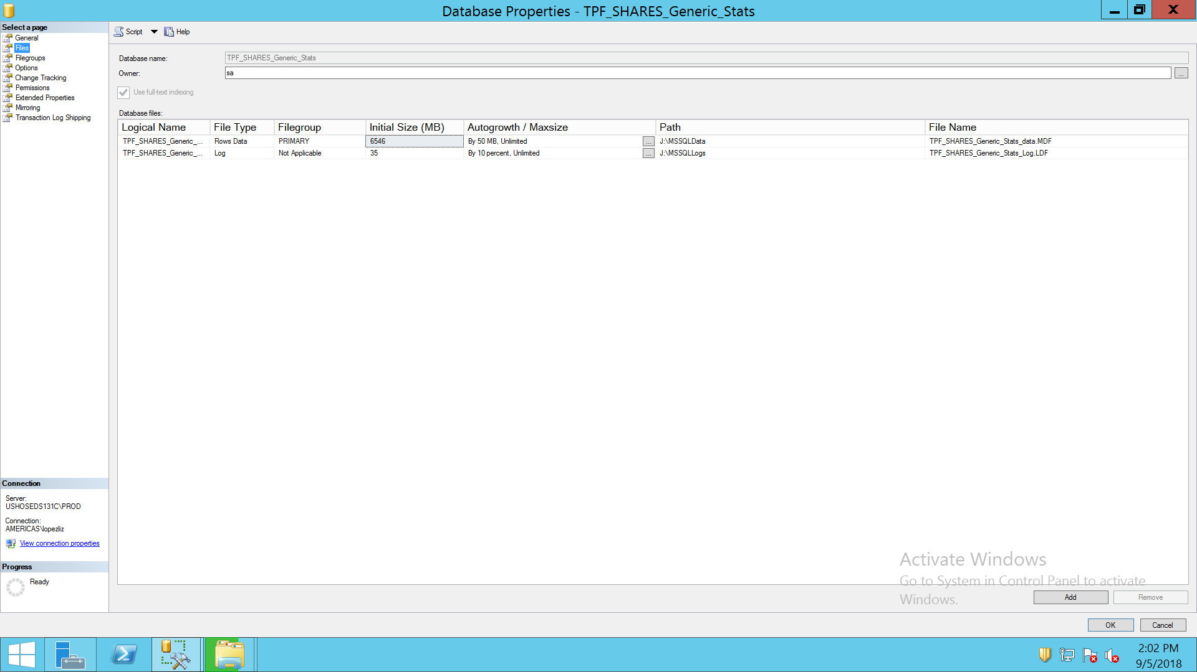

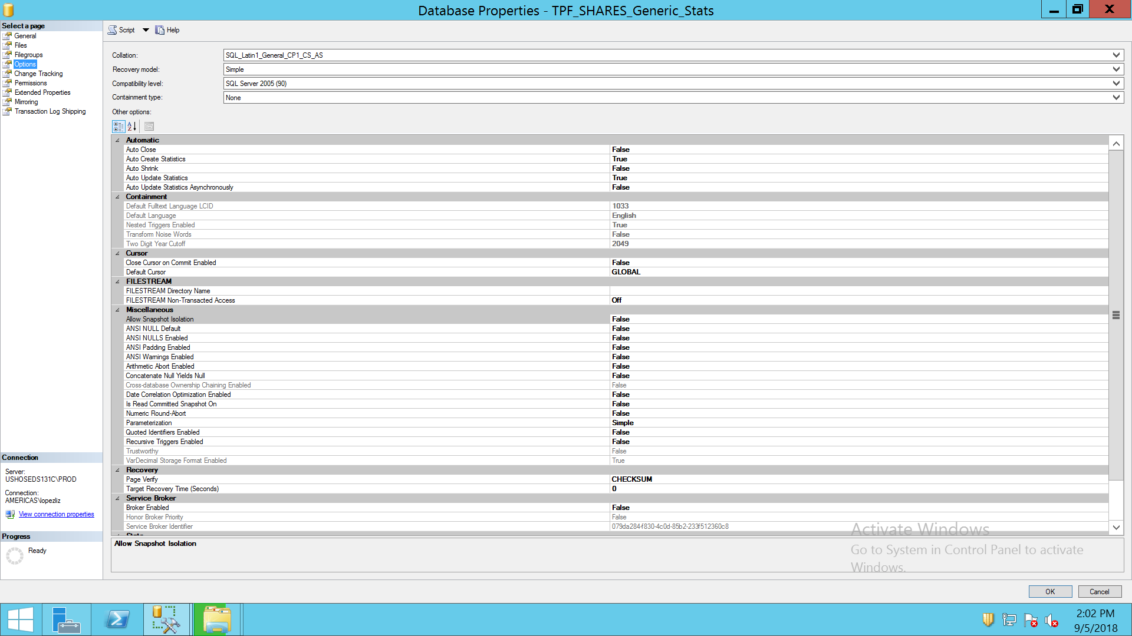

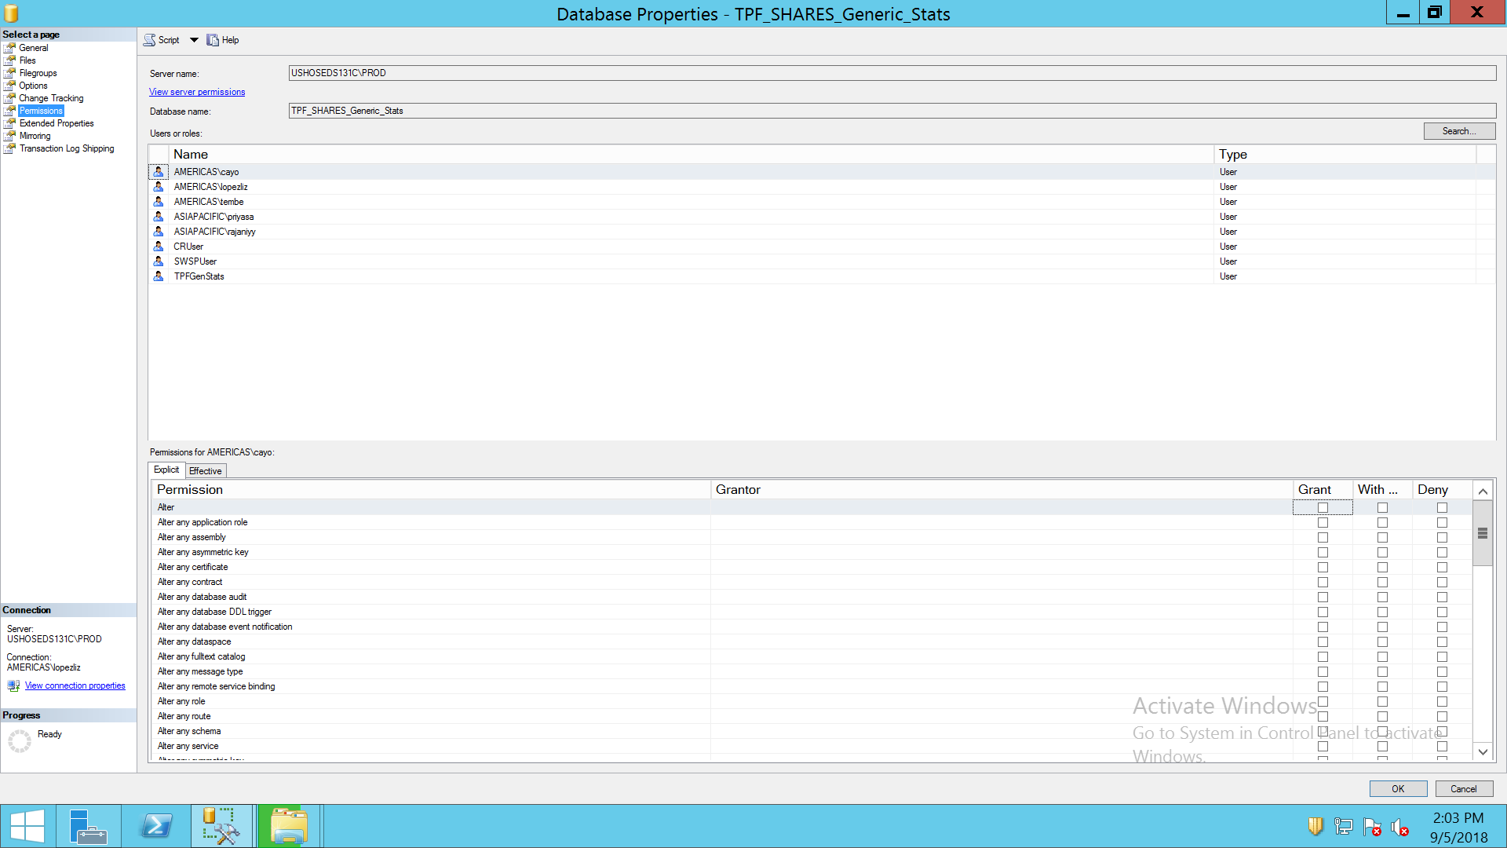

SECURITY

LOGINS

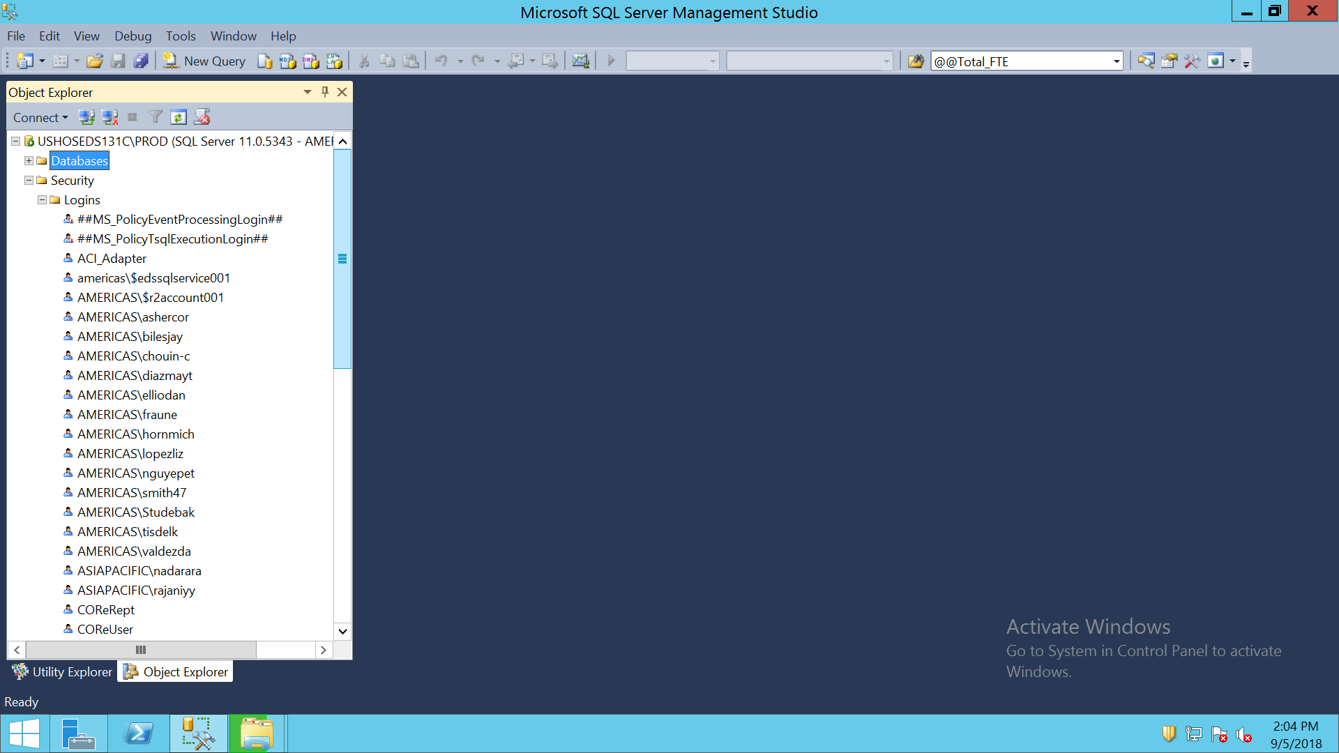

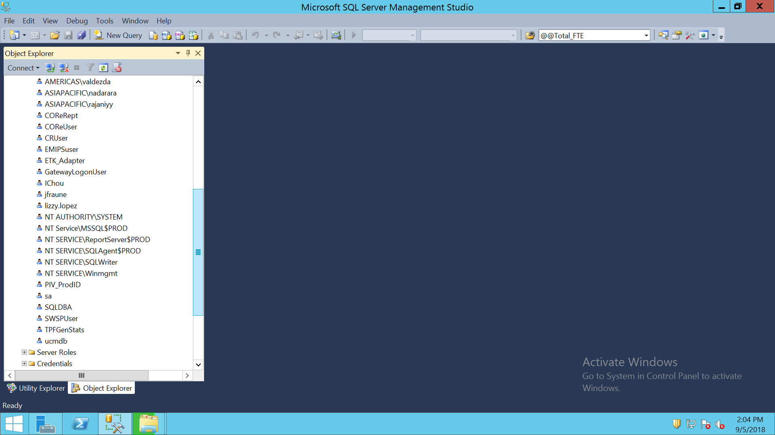

CREDENTIALS

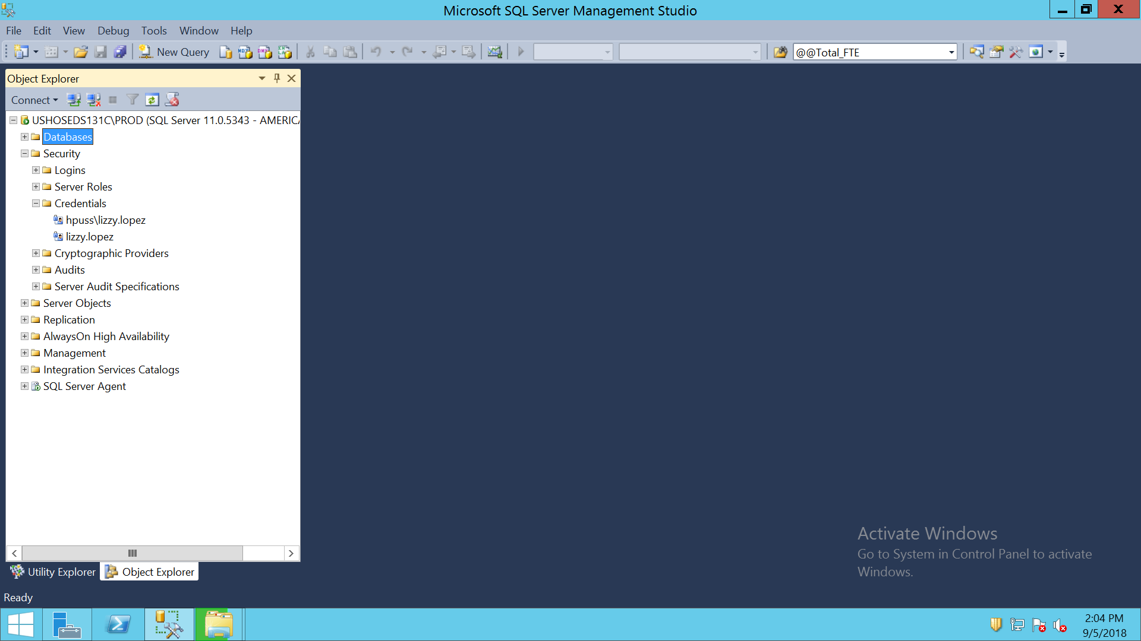

MANAGEMENT

MAINTENANCE PLANS

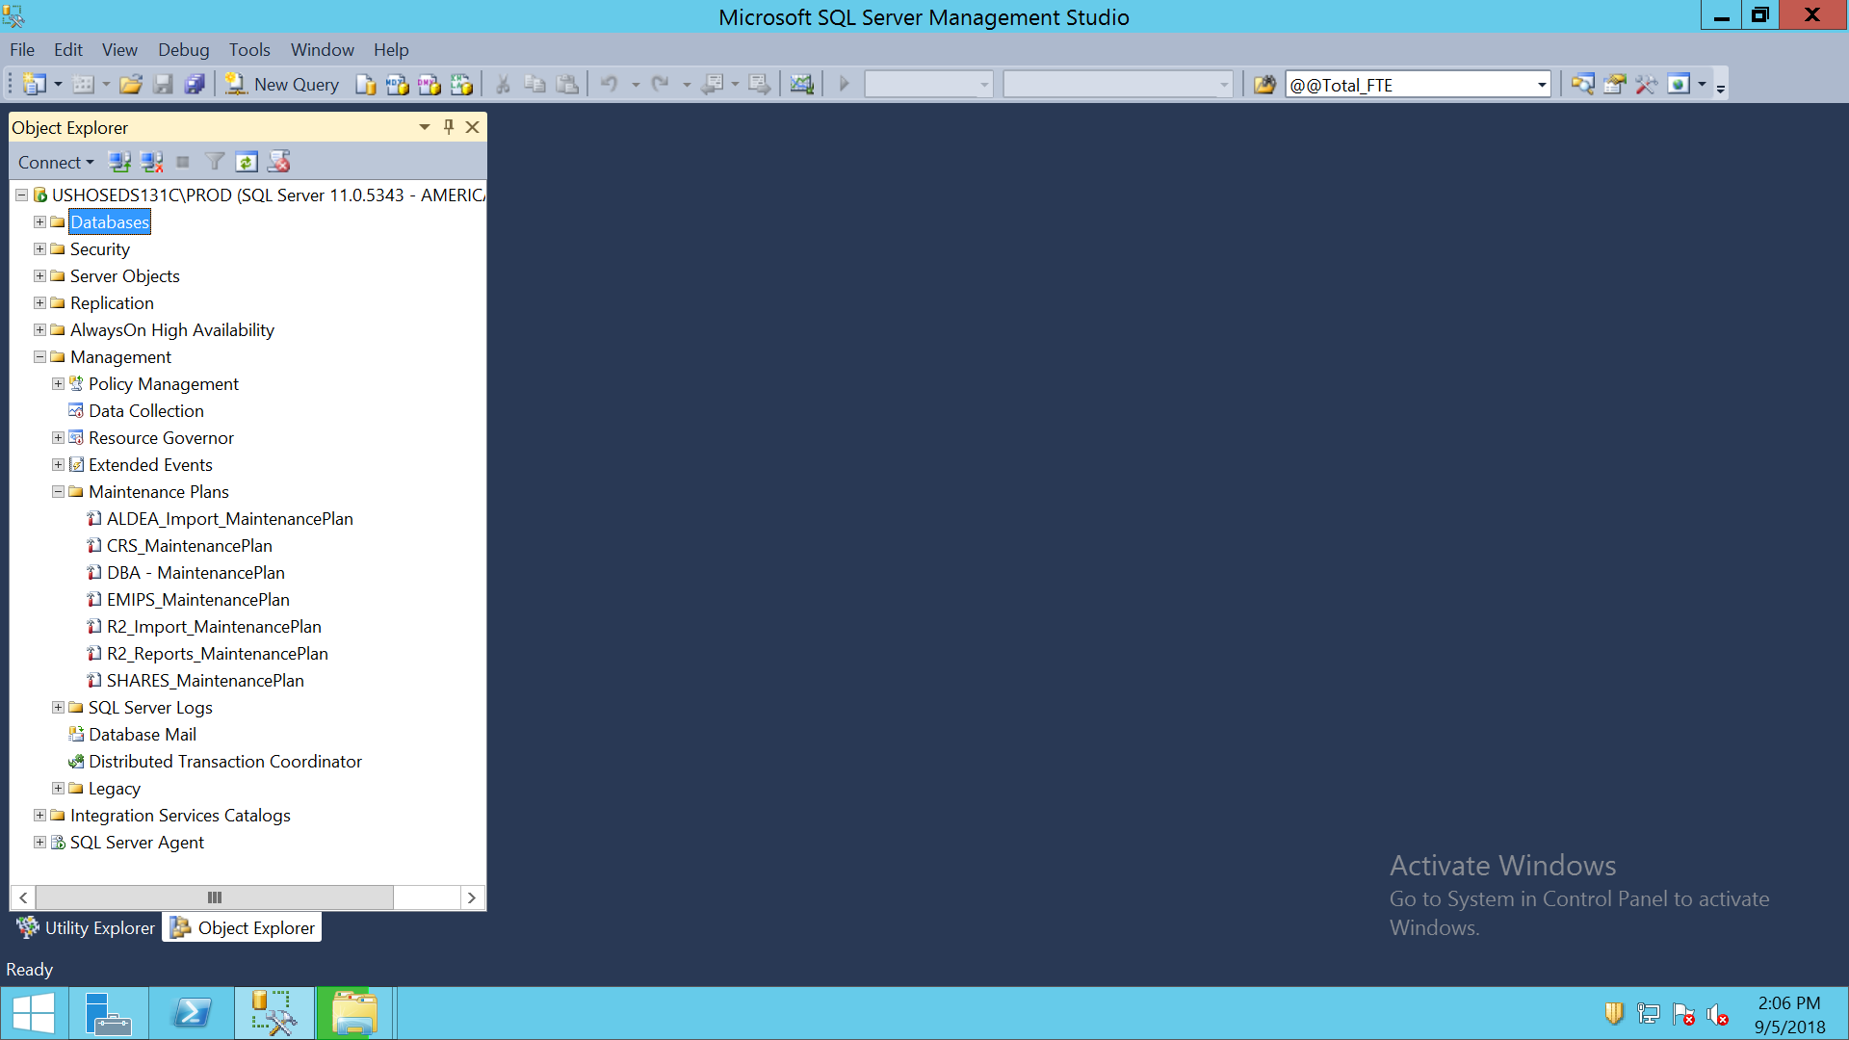

ALDEA MAINTENANCE PLAN

USE [msdb]

GO

/****** Object: Job [ALDEA_Import_MaintenancePlan.Subplan_1] Script Date: 9/5/2018 2:10:43 PM ******/

BEGIN TRANSACTION

DECLARE @ReturnCode INT

SELECT @ReturnCode = 0

/****** Object: JobCategory [Database Maintenance] Script Date: 9/5/2018 2:10:43 PM ******/

IF NOT EXISTS (SELECT name FROM msdb.dbo.syscategories WHERE name=N'Database Maintenance' AND category_class=1)

BEGIN

EXEC @ReturnCode = msdb.dbo.sp_add_category @class=N'JOB', @type=N'LOCAL', @name=N'Database Maintenance'

IF (@@ERROR <> 0 OR @ReturnCode <> 0) GOTO QuitWithRollback

END

DECLARE @jobId BINARY(16)

EXEC @ReturnCode = msdb.dbo.sp_add_job @job_name=N'ALDEA_Import_MaintenancePlan.Subplan_1',

@enabled=1,

@notify_level_eventlog=2,

@notify_level_email=0,

@notify_level_netsend=0,

@notify_level_page=0,

@delete_level=0,

@description=N'No description available.',

@category_name=N'Database Maintenance',

@owner_login_name=N'sa', @job_id = @jobId OUTPUT

IF (@@ERROR <> 0 OR @ReturnCode <> 0) GOTO QuitWithRollback

/****** Object: Step [Subplan_1] Script Date: 9/5/2018 2:10:43 PM ******/

EXEC @ReturnCode = msdb.dbo.sp_add_jobstep @job_id=@jobId, @step_name=N'Subplan_1',

@step_id=1,

@cmdexec_success_code=0,

@on_success_action=1,

@on_success_step_id=0,

@on_fail_action=2,

@on_fail_step_id=0,

@retry_attempts=0,

@retry_interval=0,

@os_run_priority=0, @subsystem=N'SSIS',

@command=N'/SQL "\"Maintenance Plans\ALDEA_Import_MaintenancePlan\"" /SERVER "\"USHOSEDS131C\PROD\"" /CHECKPOINTING OFF /SET "\"\Package\Subplan_1.Disable\"";false /REPORTING E',

@flags=0

IF (@@ERROR <> 0 OR @ReturnCode <> 0) GOTO QuitWithRollback

EXEC @ReturnCode = msdb.dbo.sp_update_job @job_id = @jobId, @start_step_id = 1

IF (@@ERROR <> 0 OR @ReturnCode <> 0) GOTO QuitWithRollback

EXEC @ReturnCode = msdb.dbo.sp_add_jobschedule @job_id=@jobId, @name=N'ALDEA_Import_MaintenancePlan',

@enabled=1,

@freq_type=4,

@freq_interval=1,

@freq_subday_type=1,

@freq_subday_interval=0,

@freq_relative_interval=0,

@freq_recurrence_factor=0,

@active_start_date=20150527,

@active_end_date=99991231,

@active_start_time=213000,

@active_end_time=235959,

@schedule_uid=N'8ebb4dcc-11b8-4158-8fdd-2ac1b8d66c68'

IF (@@ERROR <> 0 OR @ReturnCode <> 0) GOTO QuitWithRollback

EXEC @ReturnCode = msdb.dbo.sp_add_jobserver @job_id = @jobId, @server_name = N'(local)'

IF (@@ERROR <> 0 OR @ReturnCode <> 0) GOTO QuitWithRollback

COMMIT TRANSACTION

GOTO EndSave

QuitWithRollback:

IF (@@TRANCOUNT > 0) ROLLBACK TRANSACTION

EndSave:

GO

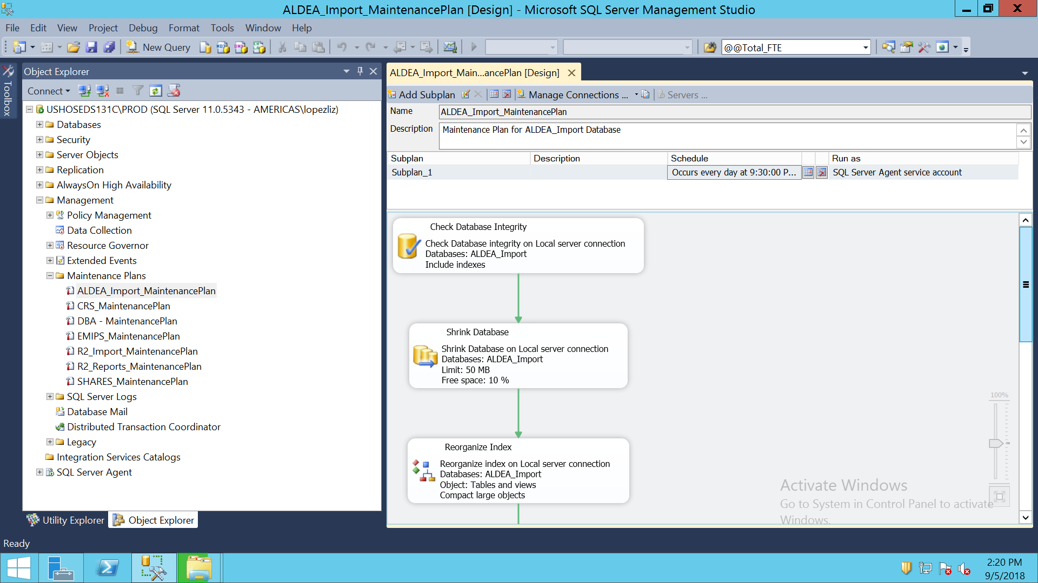

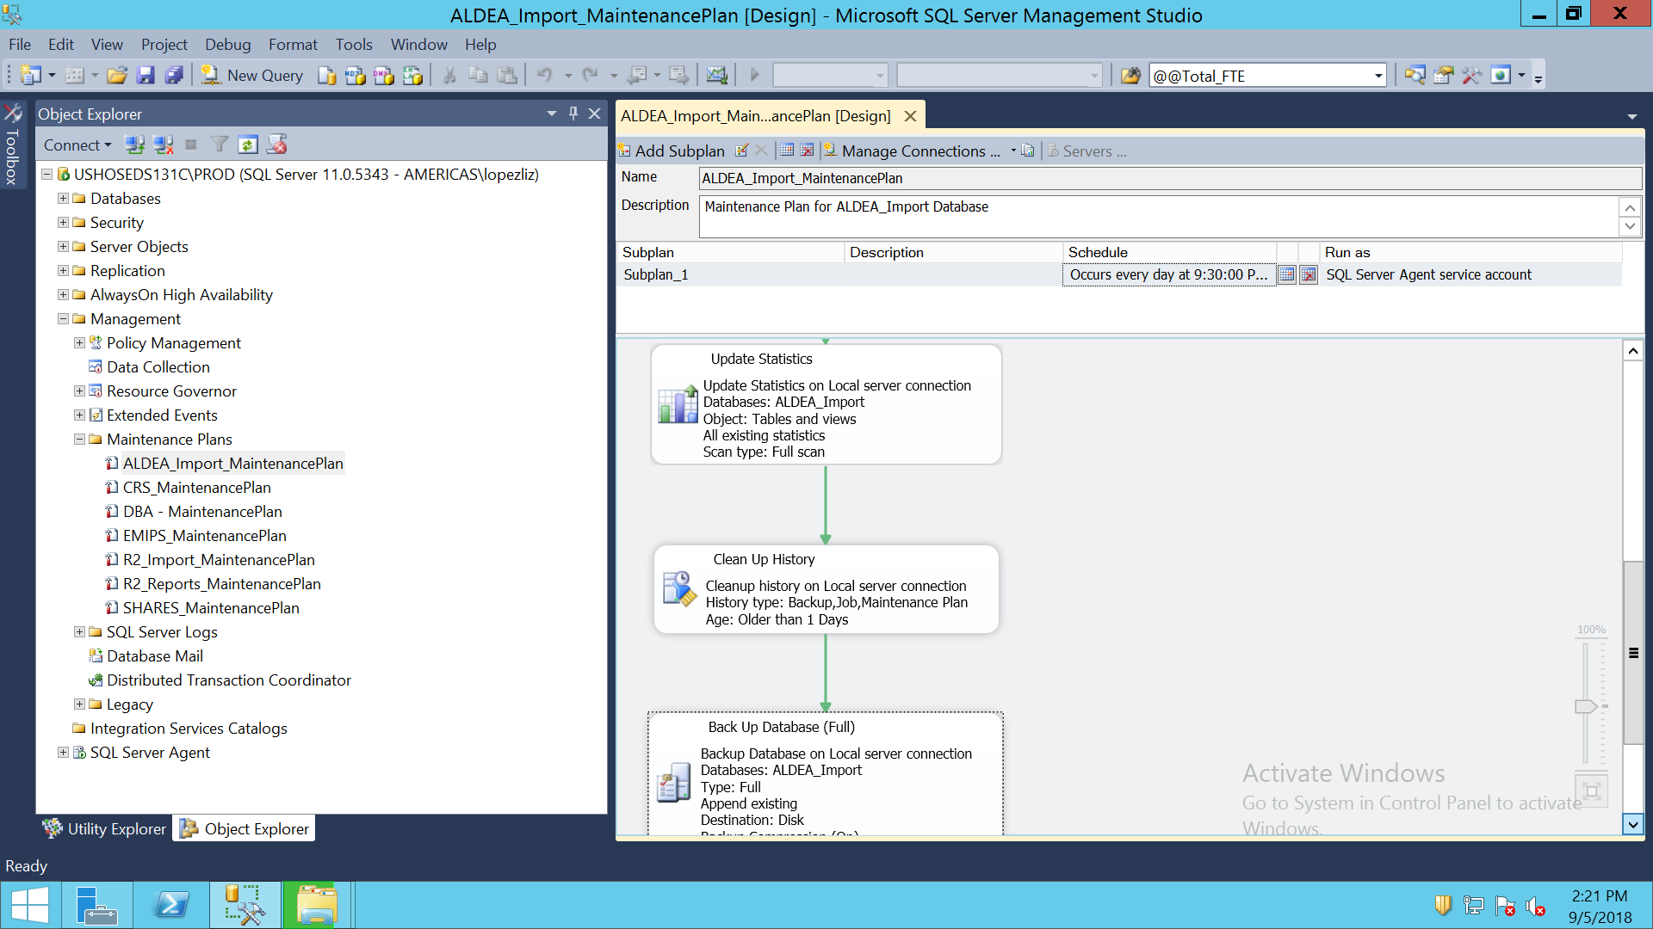

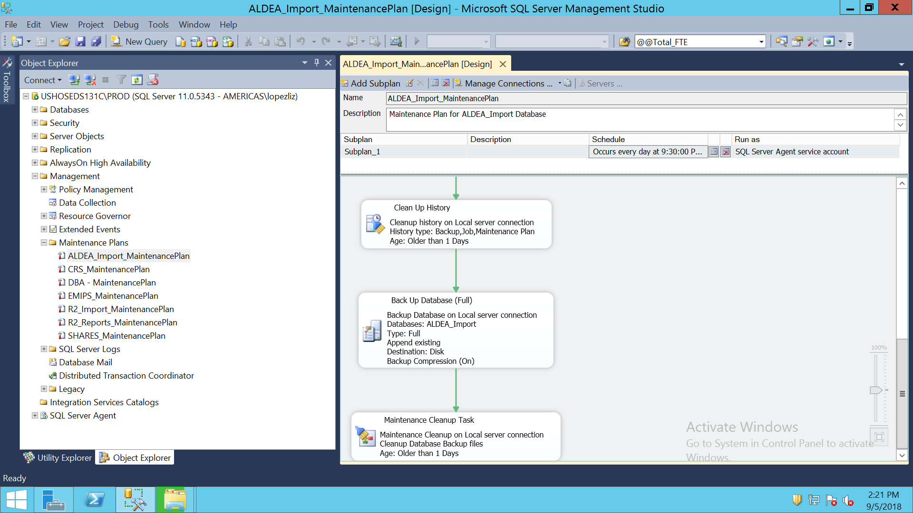

COMPUTE SERVICES MAINTENANCE PLAN

USE [msdb]

GO

/****** Object: Job [CRS_MaintenancePlan.Subplan_1] Script Date: 9/5/2018 2:11:33 PM ******/

BEGIN TRANSACTION

DECLARE @ReturnCode INT

SELECT @ReturnCode = 0

/****** Object: JobCategory [Database Maintenance] Script Date: 9/5/2018 2:11:33 PM ******/

IF NOT EXISTS (SELECT name FROM msdb.dbo.syscategories WHERE name=N'Database Maintenance' AND category_class=1)

BEGIN

EXEC @ReturnCode = msdb.dbo.sp_add_category @class=N'JOB', @type=N'LOCAL', @name=N'Database Maintenance'

IF (@@ERROR <> 0 OR @ReturnCode <> 0) GOTO QuitWithRollback

END

DECLARE @jobId BINARY(16)

EXEC @ReturnCode = msdb.dbo.sp_add_job @job_name=N'CRS_MaintenancePlan.Subplan_1',

@enabled=1,

@notify_level_eventlog=2,

@notify_level_email=0,

@notify_level_netsend=0,

@notify_level_page=0,

@delete_level=0,

@description=N'No description available.',

@category_name=N'Database Maintenance',

@owner_login_name=N'sa', @job_id = @jobId OUTPUT

IF (@@ERROR <> 0 OR @ReturnCode <> 0) GOTO QuitWithRollback

/****** Object: Step [Subplan_1] Script Date: 9/5/2018 2:11:33 PM ******/

EXEC @ReturnCode = msdb.dbo.sp_add_jobstep @job_id=@jobId, @step_name=N'Subplan_1',

@step_id=1,

@cmdexec_success_code=0,

@on_success_action=1,

@on_success_step_id=0,

@on_fail_action=2,

@on_fail_step_id=0,

@retry_attempts=0,

@retry_interval=0,

@os_run_priority=0, @subsystem=N'SSIS',

@command=N'/Server "$(ESCAPE_NONE(SRVR))" /SQL "Maintenance Plans\CRS_MaintenancePlan" /set "\Package\Subplan_1.Disable;false"',

@flags=0

IF (@@ERROR <> 0 OR @ReturnCode <> 0) GOTO QuitWithRollback

EXEC @ReturnCode = msdb.dbo.sp_update_job @job_id = @jobId, @start_step_id = 1

IF (@@ERROR <> 0 OR @ReturnCode <> 0) GOTO QuitWithRollback

EXEC @ReturnCode = msdb.dbo.sp_add_jobschedule @job_id=@jobId, @name=N'CRS_MaintenancePlan',

@enabled=1,

@freq_type=4,

@freq_interval=1,

@freq_subday_type=1,

@freq_subday_interval=0,

@freq_relative_interval=0,

@freq_recurrence_factor=0,

@active_start_date=20161028,

@active_end_date=99991231,

@active_start_time=210000,

@active_end_time=235959,

@schedule_uid=N'7f1a8c3f-c427-4a86-8f09-a3c42300866d'

IF (@@ERROR <> 0 OR @ReturnCode <> 0) GOTO QuitWithRollback

EXEC @ReturnCode = msdb.dbo.sp_add_jobserver @job_id = @jobId, @server_name = N'(local)'

IF (@@ERROR <> 0 OR @ReturnCode <> 0) GOTO QuitWithRollback

COMMIT TRANSACTION

GOTO EndSave

QuitWithRollback:

IF (@@TRANCOUNT > 0) ROLLBACK TRANSACTION

EndSave:

GO

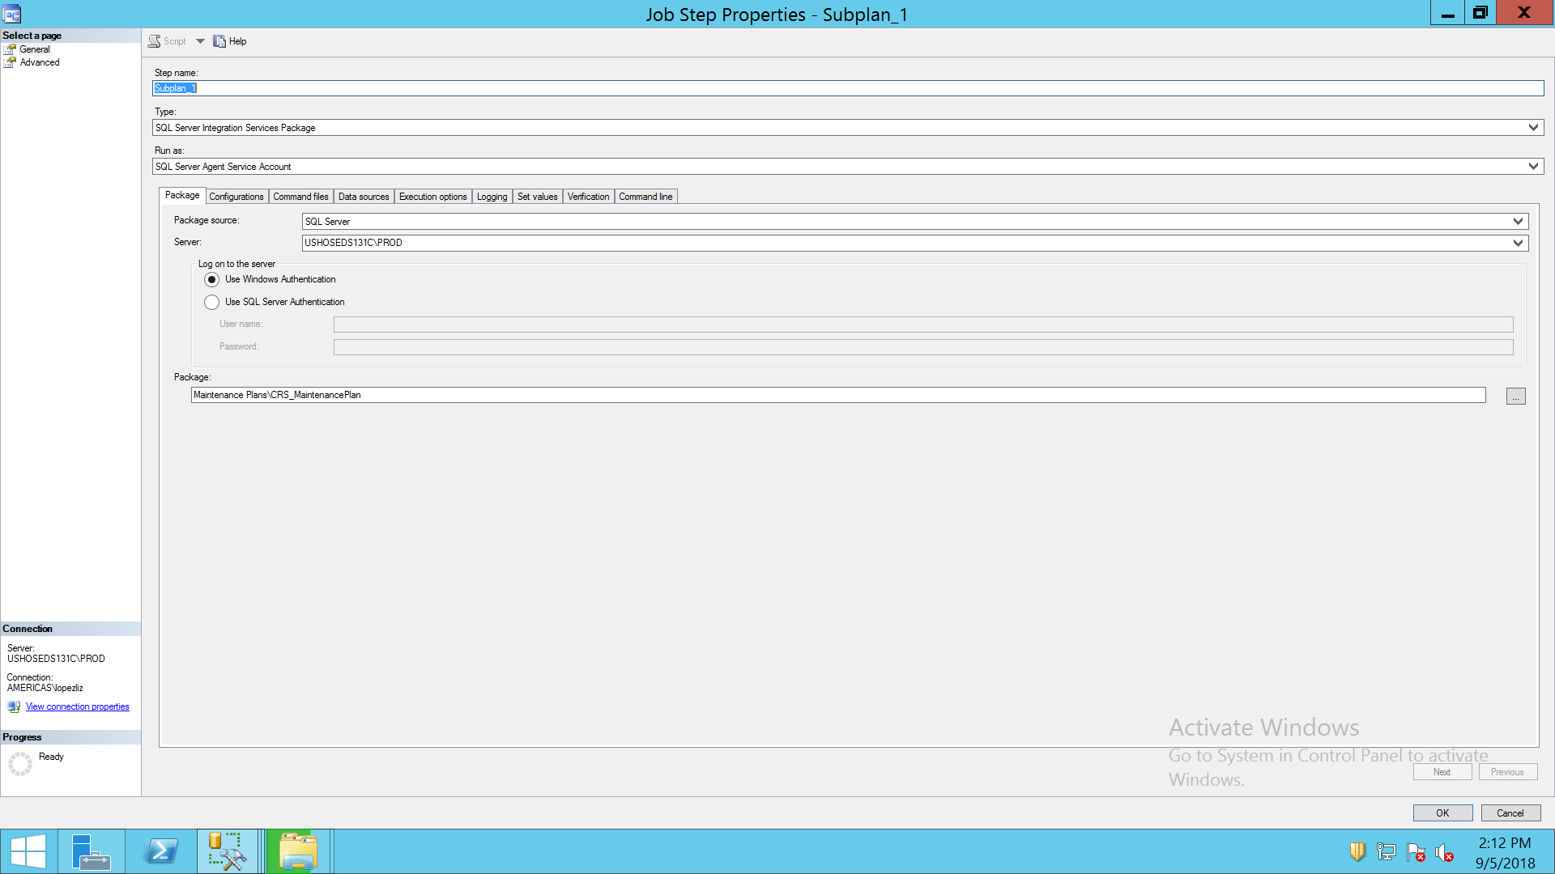

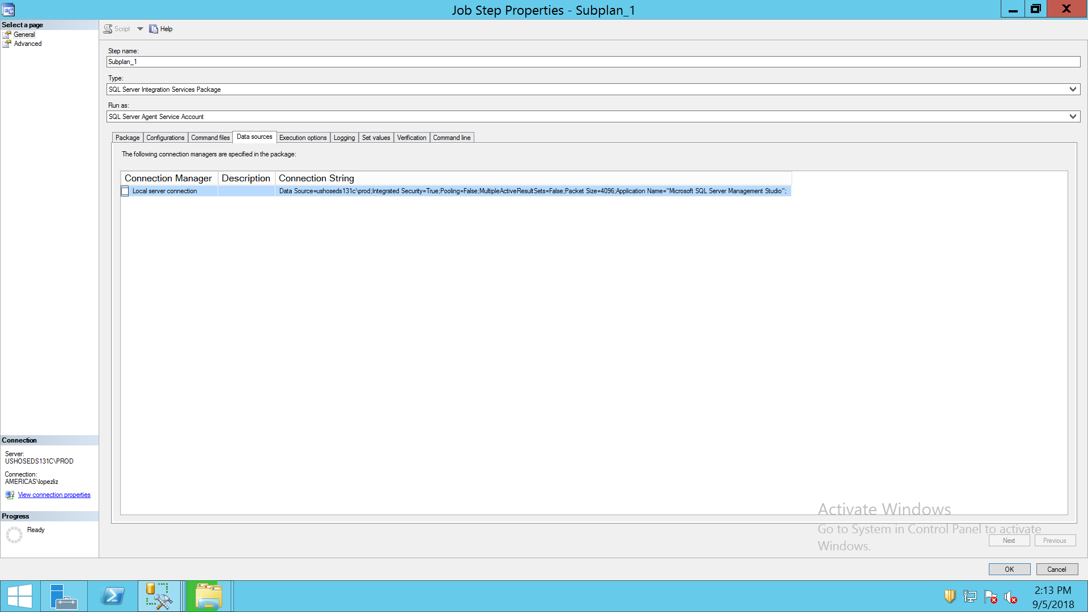

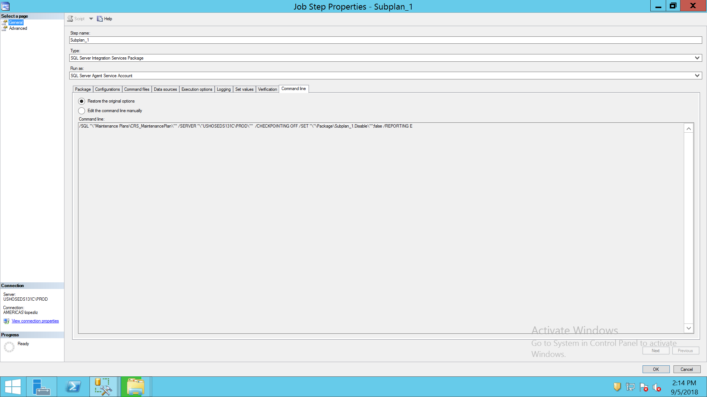

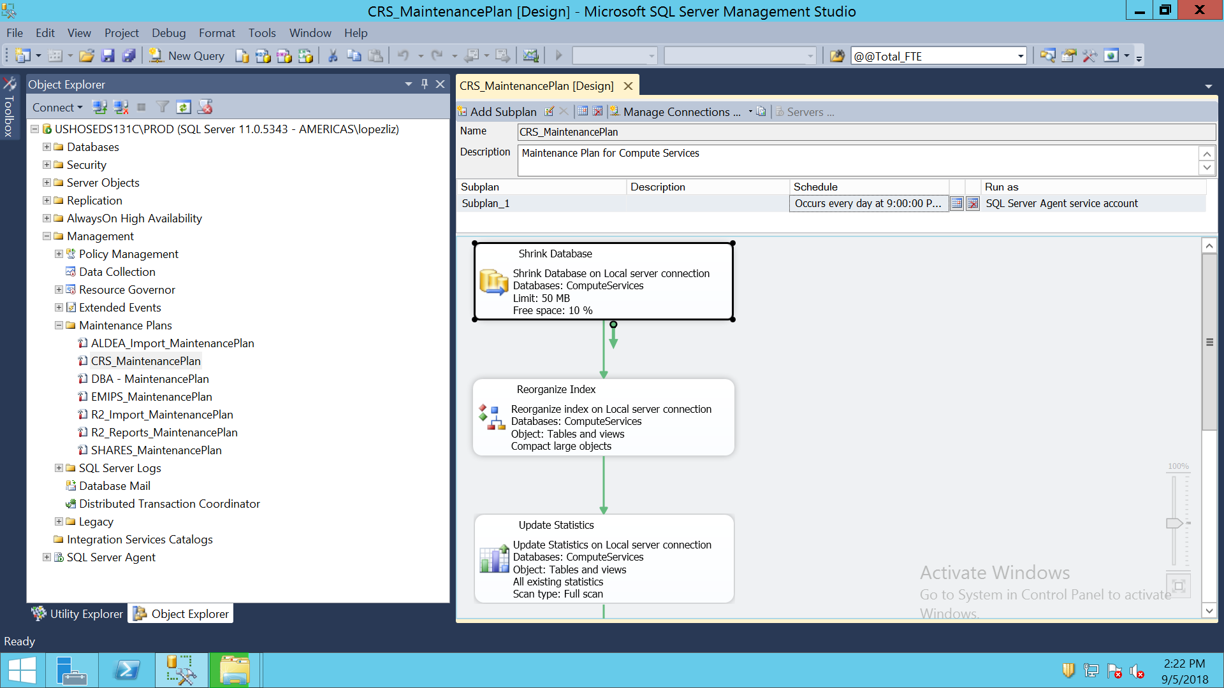

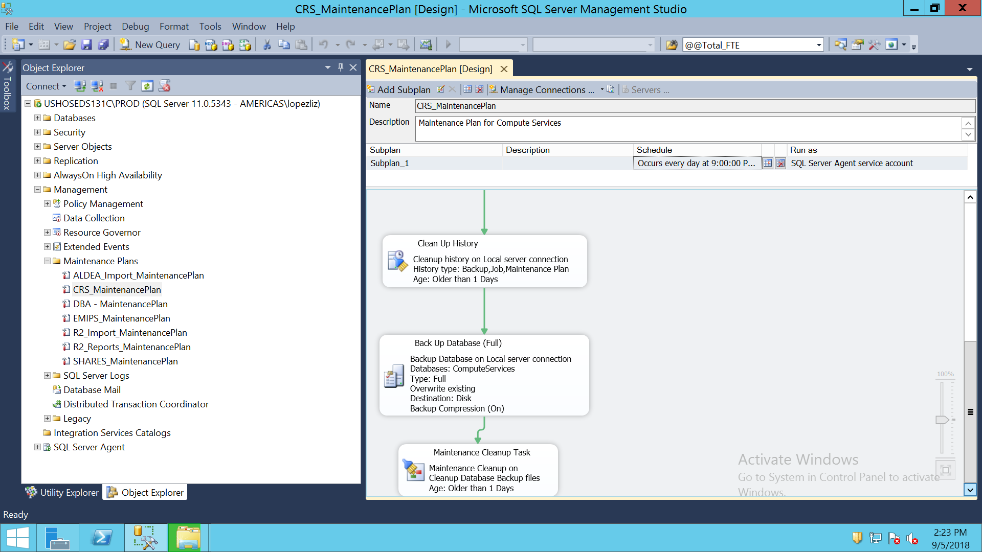

EMIPS MAINTENANCE PLAN

USE [msdb]

GO

/****** Object: Job [EMIPS_MaintenancePlan.Subplan_1] Script Date: 9/5/2018 2:14:47 PM ******/

BEGIN TRANSACTION

DECLARE @ReturnCode INT

SELECT @ReturnCode = 0

/****** Object: JobCategory [Database Maintenance] Script Date: 9/5/2018 2:14:47 PM ******/

IF NOT EXISTS (SELECT name FROM msdb.dbo.syscategories WHERE name=N'Database Maintenance' AND category_class=1)

BEGIN

EXEC @ReturnCode = msdb.dbo.sp_add_category @class=N'JOB', @type=N'LOCAL', @name=N'Database Maintenance'

IF (@@ERROR <> 0 OR @ReturnCode <> 0) GOTO QuitWithRollback

END

DECLARE @jobId BINARY(16)

EXEC @ReturnCode = msdb.dbo.sp_add_job @job_name=N'EMIPS_MaintenancePlan.Subplan_1',

@enabled=1,

@notify_level_eventlog=2,

@notify_level_email=0,

@notify_level_netsend=0,

@notify_level_page=0,

@delete_level=0,

@description=N'No description available.',

@category_name=N'Database Maintenance',

@owner_login_name=N'sa', @job_id = @jobId OUTPUT

IF (@@ERROR <> 0 OR @ReturnCode <> 0) GOTO QuitWithRollback

/****** Object: Step [Subplan_1] Script Date: 9/5/2018 2:14:47 PM ******/

EXEC @ReturnCode = msdb.dbo.sp_add_jobstep @job_id=@jobId, @step_name=N'Subplan_1',

@step_id=1,

@cmdexec_success_code=0,

@on_success_action=1,

@on_success_step_id=0,

@on_fail_action=2,

@on_fail_step_id=0,

@retry_attempts=0,

@retry_interval=0,

@os_run_priority=0, @subsystem=N'SSIS',

@command=N'/Server "$(ESCAPE_NONE(SRVR))" /SQL "Maintenance Plans\EMIPS_MaintenancePlan" /set "\Package\Subplan_1.Disable;false"',

@flags=0

IF (@@ERROR <> 0 OR @ReturnCode <> 0) GOTO QuitWithRollback

EXEC @ReturnCode = msdb.dbo.sp_update_job @job_id = @jobId, @start_step_id = 1

IF (@@ERROR <> 0 OR @ReturnCode <> 0) GOTO QuitWithRollback

EXEC @ReturnCode = msdb.dbo.sp_add_jobschedule @job_id=@jobId, @name=N'EMIPS_MaintenancePlan.Subplan_1',

@enabled=1,

@freq_type=4,

@freq_interval=1,

@freq_subday_type=1,

@freq_subday_interval=0,

@freq_relative_interval=0,

@freq_recurrence_factor=0,

@active_start_date=20150504,

@active_end_date=99991231,

@active_start_time=230000,

@active_end_time=235959,

@schedule_uid=N'b8c54084-e8c4-4798-bfca-4c5554cb0591'

IF (@@ERROR <> 0 OR @ReturnCode <> 0) GOTO QuitWithRollback

EXEC @ReturnCode = msdb.dbo.sp_add_jobserver @job_id = @jobId, @server_name = N'(local)'

IF (@@ERROR <> 0 OR @ReturnCode <> 0) GOTO QuitWithRollback

COMMIT TRANSACTION

GOTO EndSave

QuitWithRollback:

IF (@@TRANCOUNT > 0) ROLLBACK TRANSACTION

EndSave:

GO

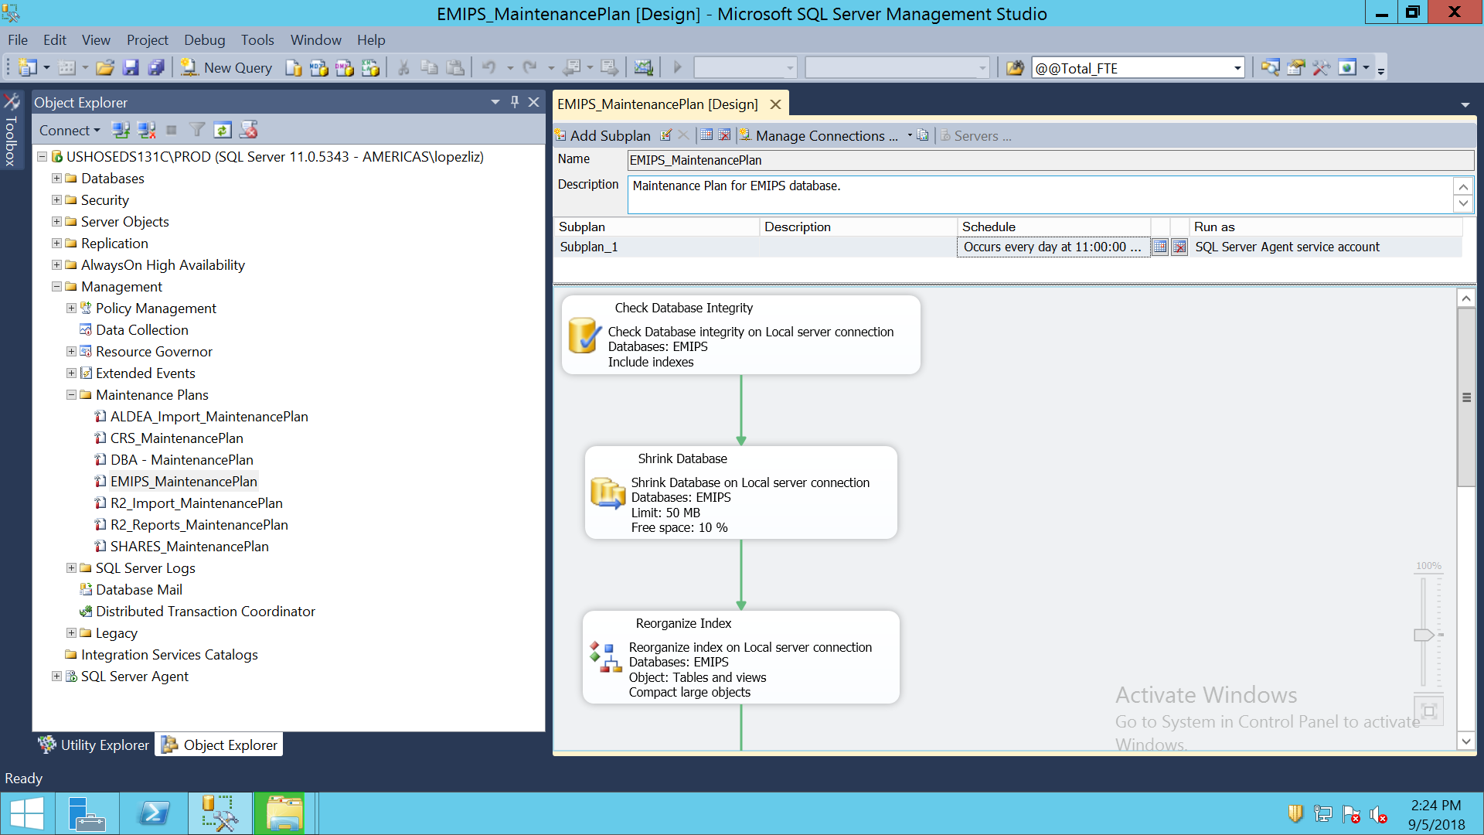

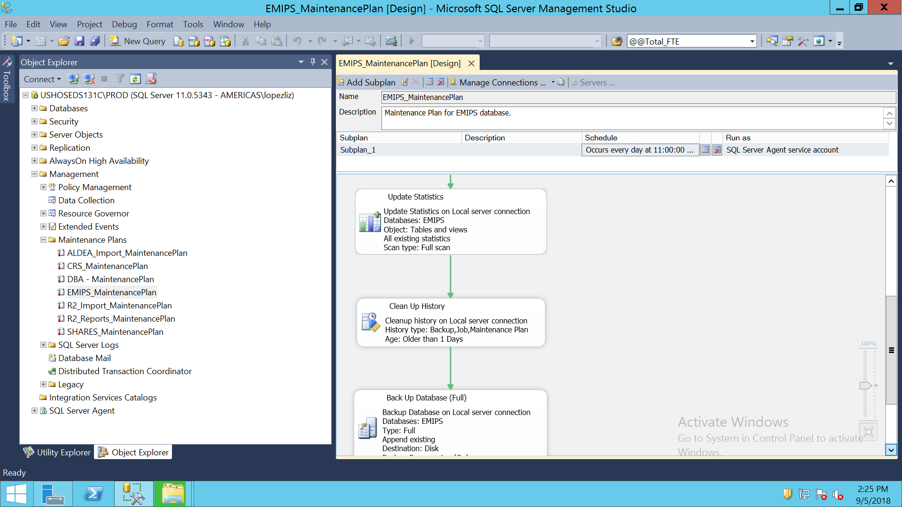

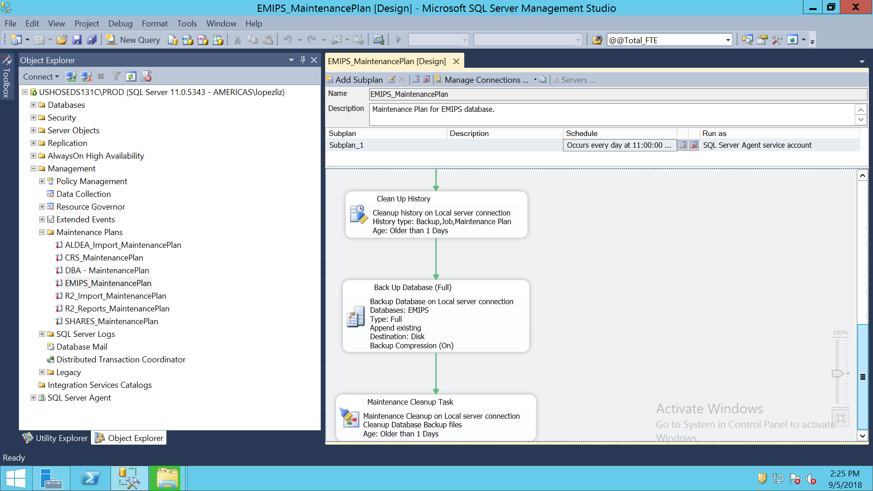

R2_IMPORT MAINTENANCE PLAN

USE [msdb]

GO

/****** Object: Job [R2_Import_MaintenancePlan.Subplan_1] Script Date: 9/5/2018 2:16:19 PM ******/

BEGIN TRANSACTION

DECLARE @ReturnCode INT

SELECT @ReturnCode = 0

/****** Object: JobCategory [Database Maintenance] Script Date: 9/5/2018 2:16:19 PM ******/

IF NOT EXISTS (SELECT name FROM msdb.dbo.syscategories WHERE name=N'Database Maintenance' AND category_class=1)

BEGIN

EXEC @ReturnCode = msdb.dbo.sp_add_category @class=N'JOB', @type=N'LOCAL', @name=N'Database Maintenance'

IF (@@ERROR <> 0 OR @ReturnCode <> 0) GOTO QuitWithRollback

END

DECLARE @jobId BINARY(16)

EXEC @ReturnCode = msdb.dbo.sp_add_job @job_name=N'R2_Import_MaintenancePlan.Subplan_1',

@enabled=1,

@notify_level_eventlog=2,

@notify_level_email=0,

@notify_level_netsend=0,

@notify_level_page=0,

@delete_level=0,

@description=N'No description available.',

@category_name=N'Database Maintenance',

@owner_login_name=N'sa', @job_id = @jobId OUTPUT

IF (@@ERROR <> 0 OR @ReturnCode <> 0) GOTO QuitWithRollback

/****** Object: Step [Subplan_1] Script Date: 9/5/2018 2:16:19 PM ******/

EXEC @ReturnCode = msdb.dbo.sp_add_jobstep @job_id=@jobId, @step_name=N'Subplan_1',

@step_id=1,

@cmdexec_success_code=0,

@on_success_action=1,

@on_success_step_id=0,

@on_fail_action=2,

@on_fail_step_id=0,

@retry_attempts=0,

@retry_interval=0,

@os_run_priority=0, @subsystem=N'SSIS',

@command=N'/Server "$(ESCAPE_NONE(SRVR))" /SQL "Maintenance Plans\R2_Import_MaintenancePlan" /set "\Package\Subplan_1.Disable;false"',

@flags=0

IF (@@ERROR <> 0 OR @ReturnCode <> 0) GOTO QuitWithRollback

EXEC @ReturnCode = msdb.dbo.sp_update_job @job_id = @jobId, @start_step_id = 1

IF (@@ERROR <> 0 OR @ReturnCode <> 0) GOTO QuitWithRollback

EXEC @ReturnCode = msdb.dbo.sp_add_jobschedule @job_id=@jobId, @name=N'R2_Import_MaintenancePlan',

@enabled=1,

@freq_type=4,

@freq_interval=1,

@freq_subday_type=1,

@freq_subday_interval=0,

@freq_relative_interval=0,

@freq_recurrence_factor=0,

@active_start_date=20150603,

@active_end_date=99991231,

@active_start_time=220000,

@active_end_time=235959,

@schedule_uid=N'4bdadca4-8a90-45b5-bb03-21f2cb08a91a'

IF (@@ERROR <> 0 OR @ReturnCode <> 0) GOTO QuitWithRollback

EXEC @ReturnCode = msdb.dbo.sp_add_jobserver @job_id = @jobId, @server_name = N'(local)'

IF (@@ERROR <> 0 OR @ReturnCode <> 0) GOTO QuitWithRollback

COMMIT TRANSACTION

GOTO EndSave

QuitWithRollback:

IF (@@TRANCOUNT > 0) ROLLBACK TRANSACTION

EndSave:

GO

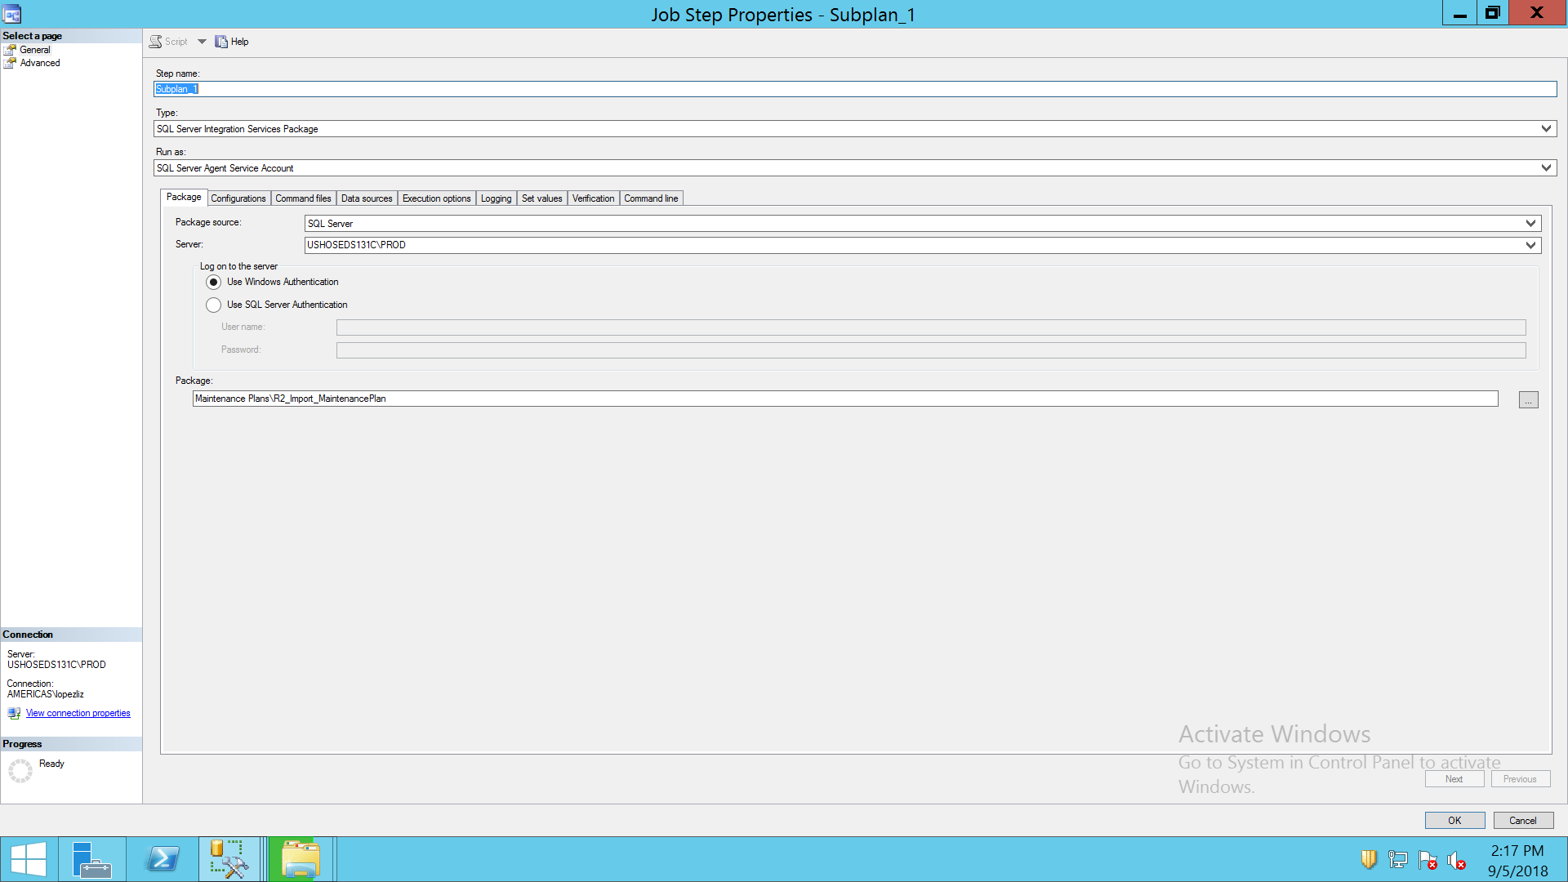

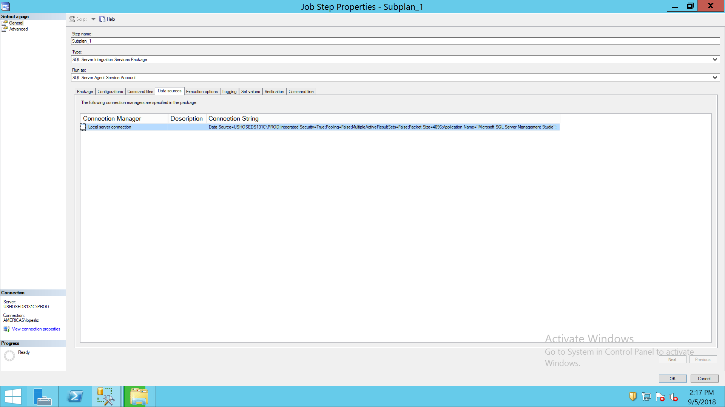

GO

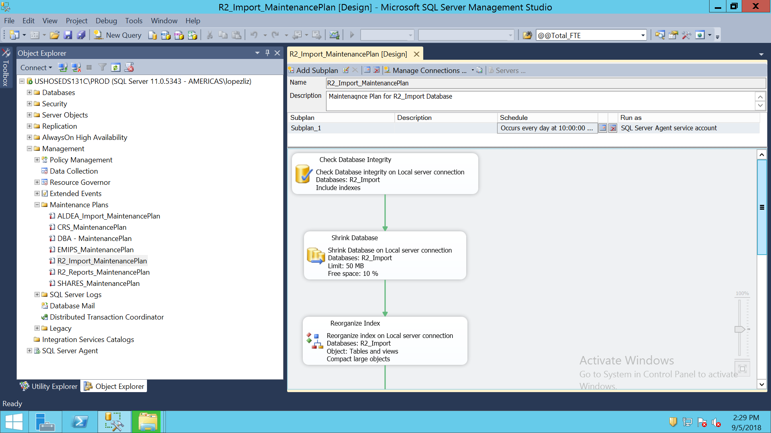

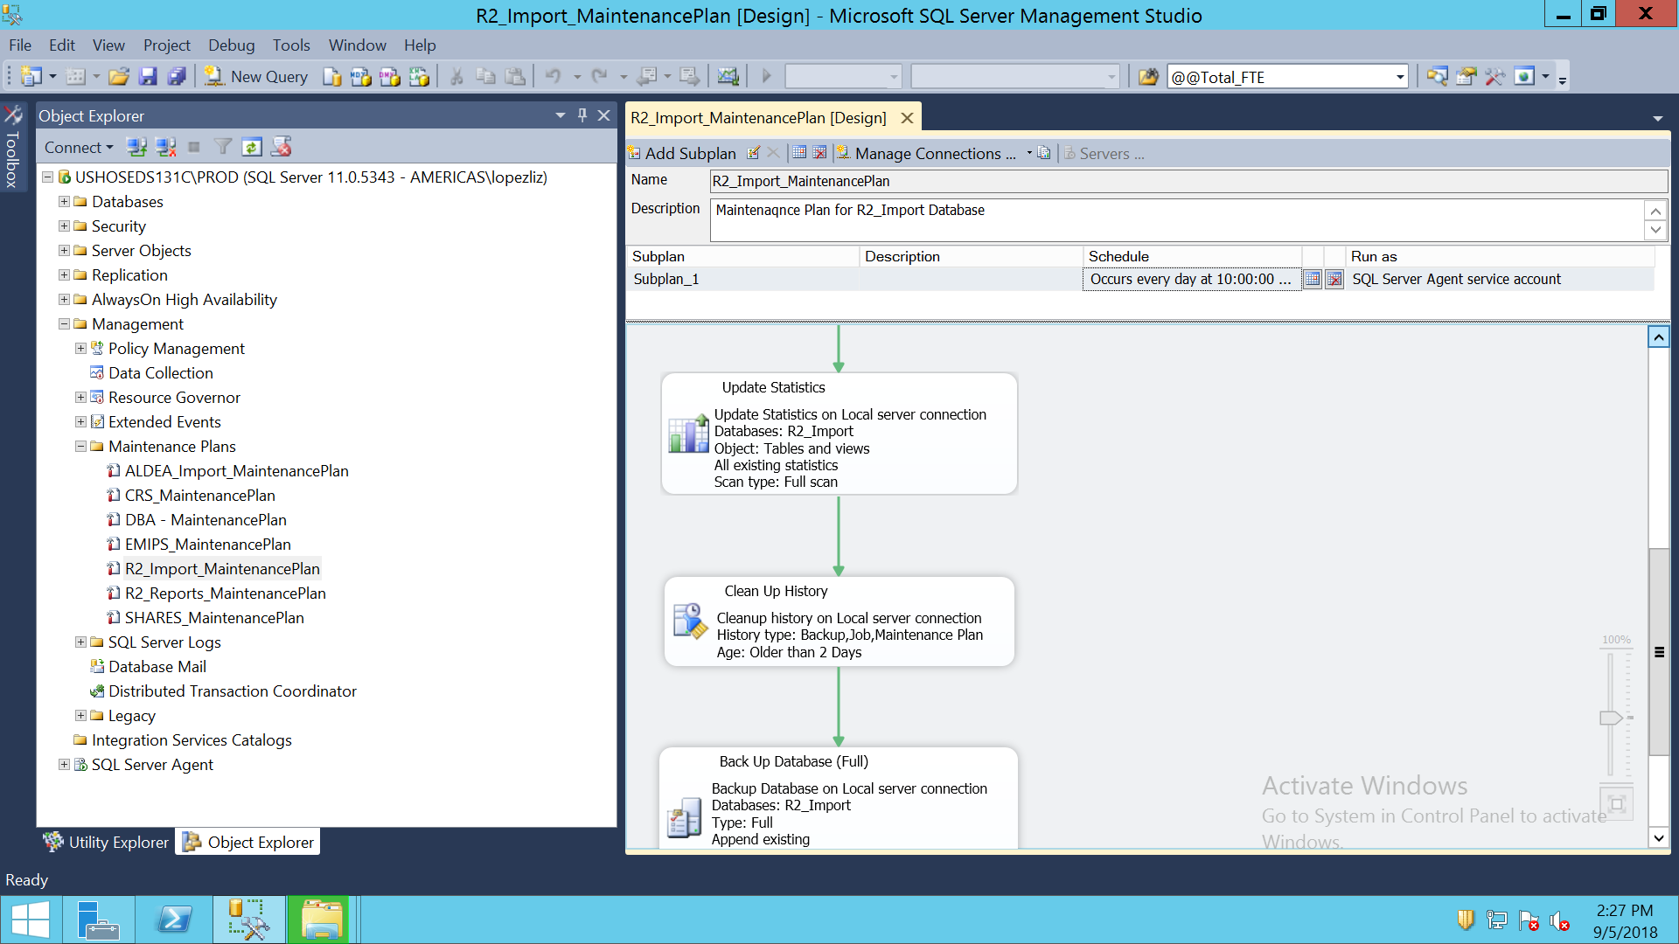

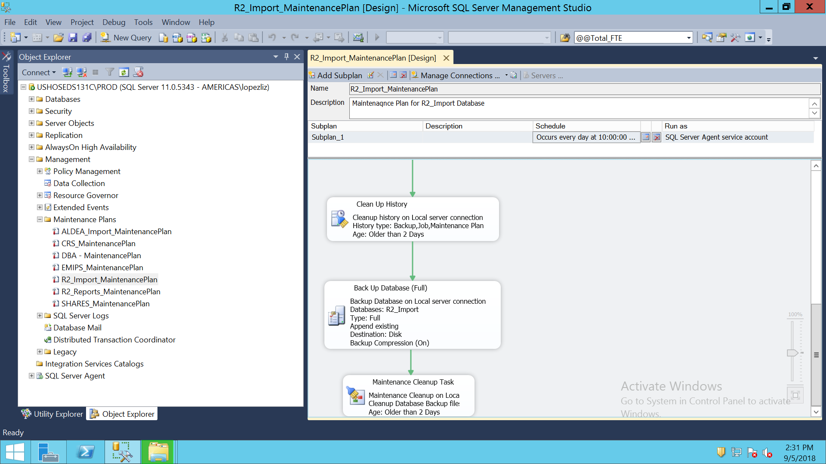

R2_REPORTS MAINTENANCE PLAN

USE [msdb]

GO

/****** Object: Job [R2_Reports_MaintenancePlan.Subplan_1] Script Date: 9/5/2018 2:18:16 PM ******/

BEGIN TRANSACTION

DECLARE @ReturnCode INT

SELECT @ReturnCode = 0

/****** Object: JobCategory [Database Maintenance] Script Date: 9/5/2018 2:18:16 PM ******/

IF NOT EXISTS (SELECT name FROM msdb.dbo.syscategories WHERE name=N'Database Maintenance' AND category_class=1)

BEGIN

EXEC @ReturnCode = msdb.dbo.sp_add_category @class=N'JOB', @type=N'LOCAL', @name=N'Database Maintenance'

IF (@@ERROR <> 0 OR @ReturnCode <> 0) GOTO QuitWithRollback

END

DECLARE @jobId BINARY(16)

EXEC @ReturnCode = msdb.dbo.sp_add_job @job_name=N'R2_Reports_MaintenancePlan.Subplan_1',

@enabled=1,

@notify_level_eventlog=2,

@notify_level_email=0,

@notify_level_netsend=0,

@notify_level_page=0,

@delete_level=0,

@description=N'No description available.',

@category_name=N'Database Maintenance',

@owner_login_name=N'sa', @job_id = @jobId OUTPUT

IF (@@ERROR <> 0 OR @ReturnCode <> 0) GOTO QuitWithRollback

/****** Object: Step [Subplan_1] Script Date: 9/5/2018 2:18:16 PM ******/

EXEC @ReturnCode = msdb.dbo.sp_add_jobstep @job_id=@jobId, @step_name=N'Subplan_1',

@step_id=1,

@cmdexec_success_code=0,

@on_success_action=1,

@on_success_step_id=0,

@on_fail_action=2,

@on_fail_step_id=0,

@retry_attempts=0,

@retry_interval=0,

@os_run_priority=0, @subsystem=N'SSIS',

@command=N'/Server "$(ESCAPE_NONE(SRVR))" /SQL "Maintenance Plans\R2_Reports_MaintenancePlan" /set "\Package\Subplan_1.Disable;false"',

@flags=0

IF (@@ERROR <> 0 OR @ReturnCode <> 0) GOTO QuitWithRollback

EXEC @ReturnCode = msdb.dbo.sp_update_job @job_id = @jobId, @start_step_id = 1

IF (@@ERROR <> 0 OR @ReturnCode <> 0) GOTO QuitWithRollback

EXEC @ReturnCode = msdb.dbo.sp_add_jobschedule @job_id=@jobId, @name=N'R2_Reports_MaintenancePlan',

@enabled=1,

@freq_type=4,

@freq_interval=1,

@freq_subday_type=1,

@freq_subday_interval=0,

@freq_relative_interval=0,

@freq_recurrence_factor=0,

@active_start_date=20150608,

@active_end_date=99991231,

@active_start_time=210000,

@active_end_time=235959,

@schedule_uid=N'481fee77-d030-4623-9297-85bd08fa709b'

IF (@@ERROR <> 0 OR @ReturnCode <> 0) GOTO QuitWithRollback

EXEC @ReturnCode = msdb.dbo.sp_add_jobserver @job_id = @jobId, @server_name = N'(local)'

IF (@@ERROR <> 0 OR @ReturnCode <> 0) GOTO QuitWithRollback

COMMIT TRANSACTION

GOTO EndSave

QuitWithRollback:

IF (@@TRANCOUNT > 0) ROLLBACK TRANSACTION

EndSave:

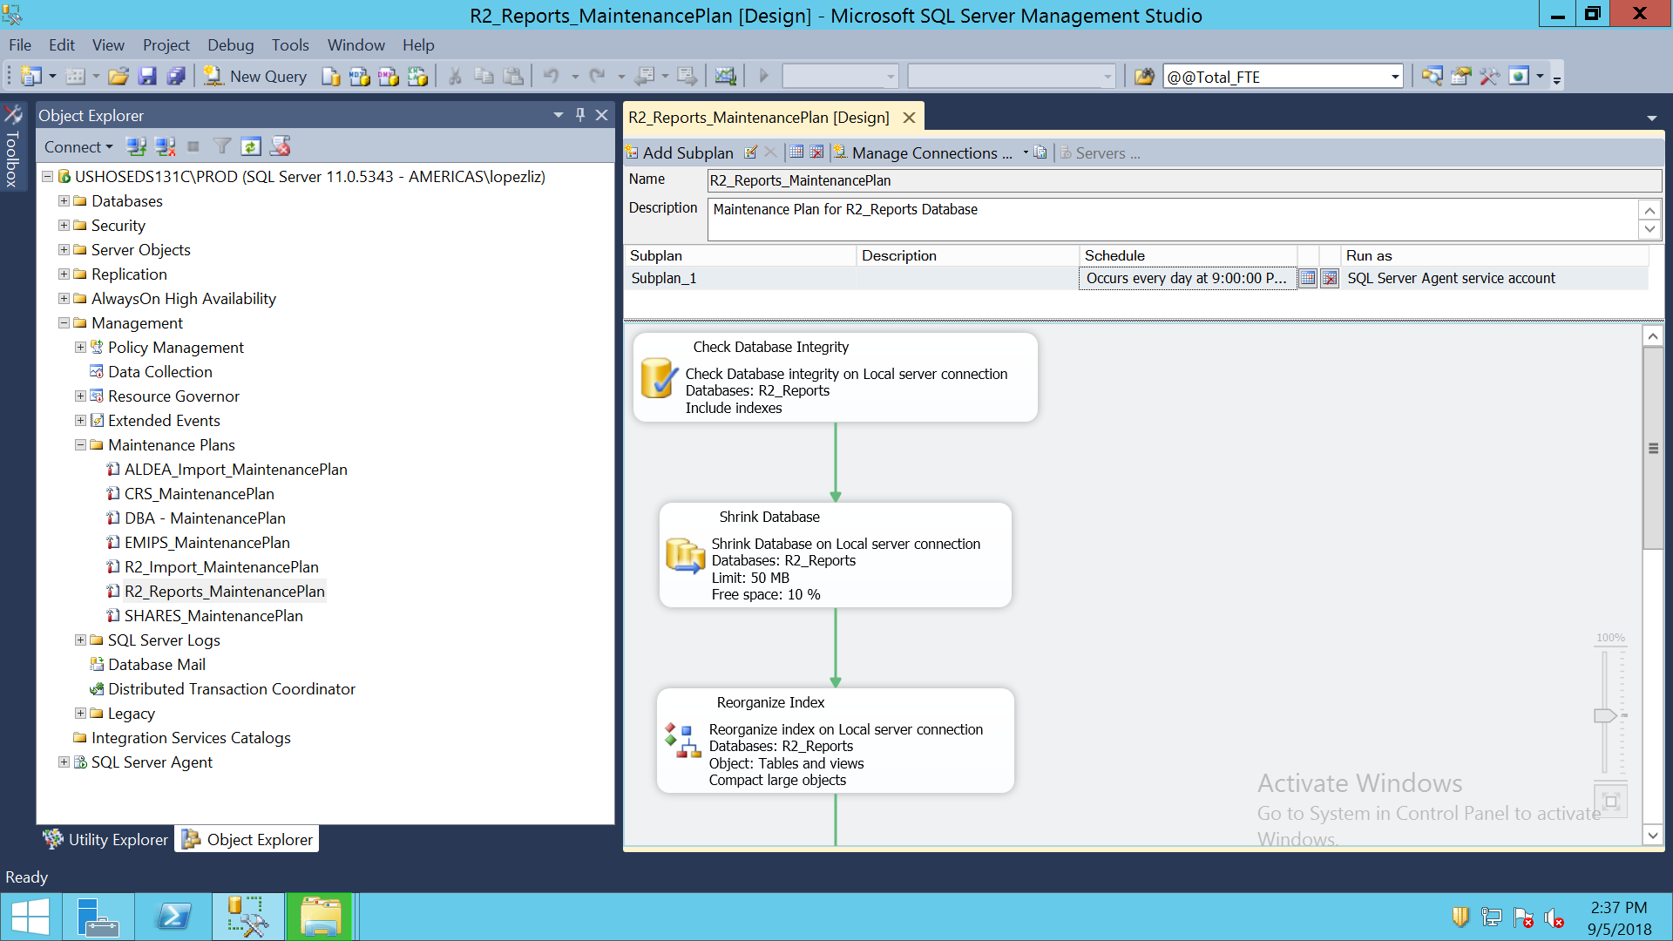

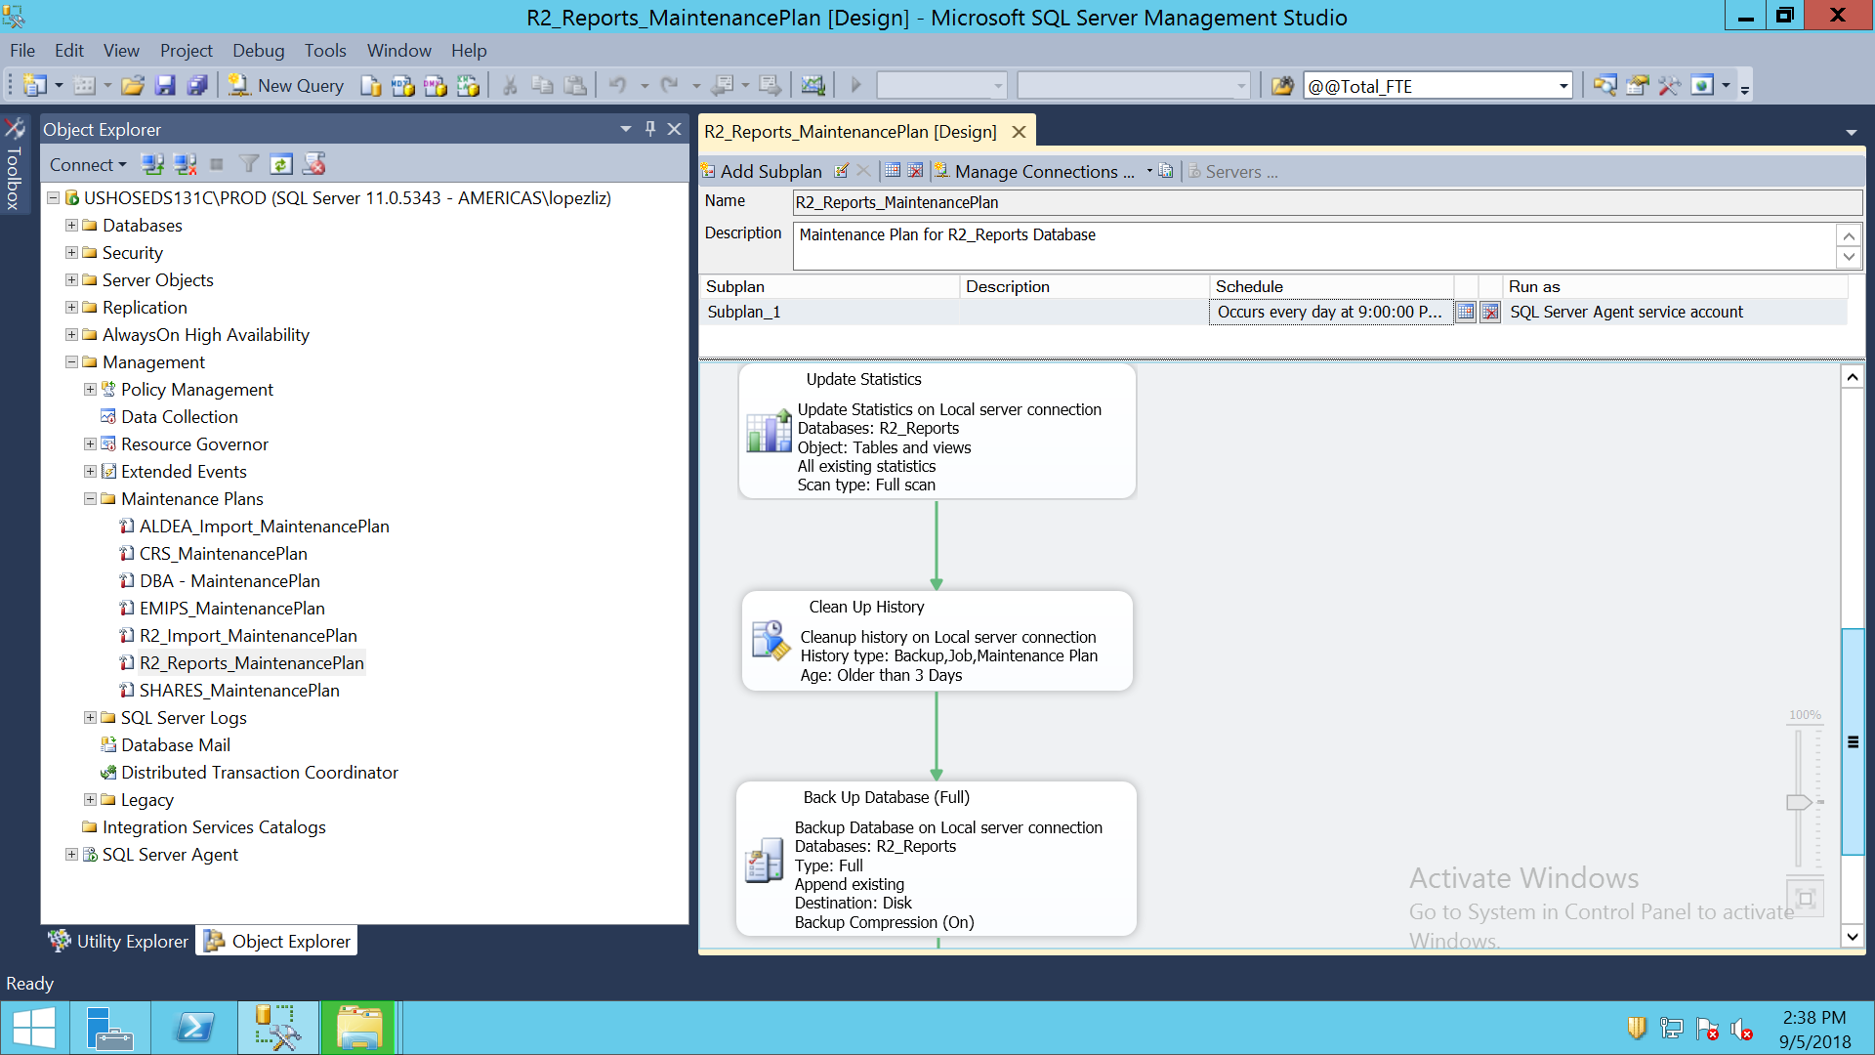

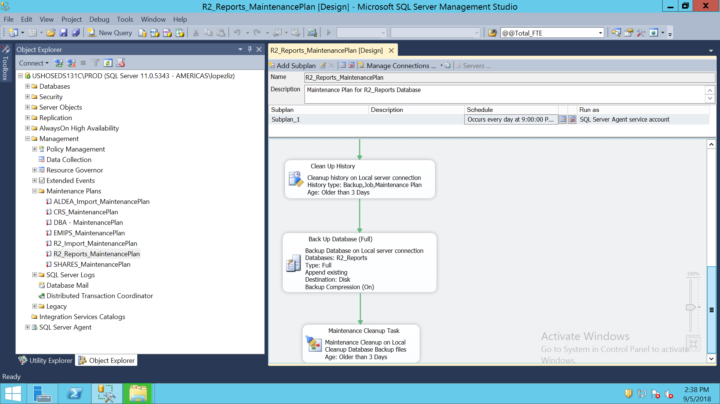

SHARES MAINTENANCE PLAN

USE [msdb]

GO

/****** Object: Job [SHARES_MaintenancePlan.Subplan_1] Script Date: 9/5/2018 2:18:48 PM ******/

BEGIN TRANSACTION

DECLARE @ReturnCode INT

SELECT @ReturnCode = 0

/****** Object: JobCategory [Database Maintenance] Script Date: 9/5/2018 2:18:48 PM ******/

IF NOT EXISTS (SELECT name FROM msdb.dbo.syscategories WHERE name=N'Database Maintenance' AND category_class=1)

BEGIN

EXEC @ReturnCode = msdb.dbo.sp_add_category @class=N'JOB', @type=N'LOCAL', @name=N'Database Maintenance'

IF (@@ERROR <> 0 OR @ReturnCode <> 0) GOTO QuitWithRollback

END

DECLARE @jobId BINARY(16)

EXEC @ReturnCode = msdb.dbo.sp_add_job @job_name=N'SHARES_MaintenancePlan.Subplan_1',

@enabled=1,

@notify_level_eventlog=2,

@notify_level_email=0,

@notify_level_netsend=0,

@notify_level_page=0,

@delete_level=0,

@description=N'No description available.',

@category_name=N'Database Maintenance',

@owner_login_name=N'sa', @job_id = @jobId OUTPUT

IF (@@ERROR <> 0 OR @ReturnCode <> 0) GOTO QuitWithRollback

/****** Object: Step [Subplan_1] Script Date: 9/5/2018 2:18:48 PM ******/

EXEC @ReturnCode = msdb.dbo.sp_add_jobstep @job_id=@jobId, @step_name=N'Subplan_1',

@step_id=1,

@cmdexec_success_code=0,

@on_success_action=1,

@on_success_step_id=0,

@on_fail_action=2,

@on_fail_step_id=0,

@retry_attempts=0,

@retry_interval=0,

@os_run_priority=0, @subsystem=N'SSIS',

@command=N'/Server "$(ESCAPE_NONE(SRVR))" /SQL "Maintenance Plans\SHARES_MaintenancePlan" /set "\Package\Subplan_1.Disable;false"',

@flags=0

IF (@@ERROR <> 0 OR @ReturnCode <> 0) GOTO QuitWithRollback

EXEC @ReturnCode = msdb.dbo.sp_update_job @job_id = @jobId, @start_step_id = 1

IF (@@ERROR <> 0 OR @ReturnCode <> 0) GOTO QuitWithRollback

EXEC @ReturnCode = msdb.dbo.sp_add_jobschedule @job_id=@jobId, @name=N'SHARES_MaintenancePlan.Subplan_1',

@enabled=1,

@freq_type=4,

@freq_interval=1,

@freq_subday_type=1,

@freq_subday_interval=0,

@freq_relative_interval=0,

@freq_recurrence_factor=0,

@active_start_date=20151208,

@active_end_date=99991231,

@active_start_time=201500,

@active_end_time=235959,

@schedule_uid=N'e0433883-b8e7-43a9-a5c6-49f1c92689fb'

IF (@@ERROR <> 0 OR @ReturnCode <> 0) GOTO QuitWithRollback

EXEC @ReturnCode = msdb.dbo.sp_add_jobserver @job_id = @jobId, @server_name = N'(local)'

IF (@@ERROR <> 0 OR @ReturnCode <> 0) GOTO QuitWithRollback

COMMIT TRANSACTION

GOTO EndSave

QuitWithRollback:

IF (@@TRANCOUNT > 0) ROLLBACK TRANSACTION

EndSave:

GO

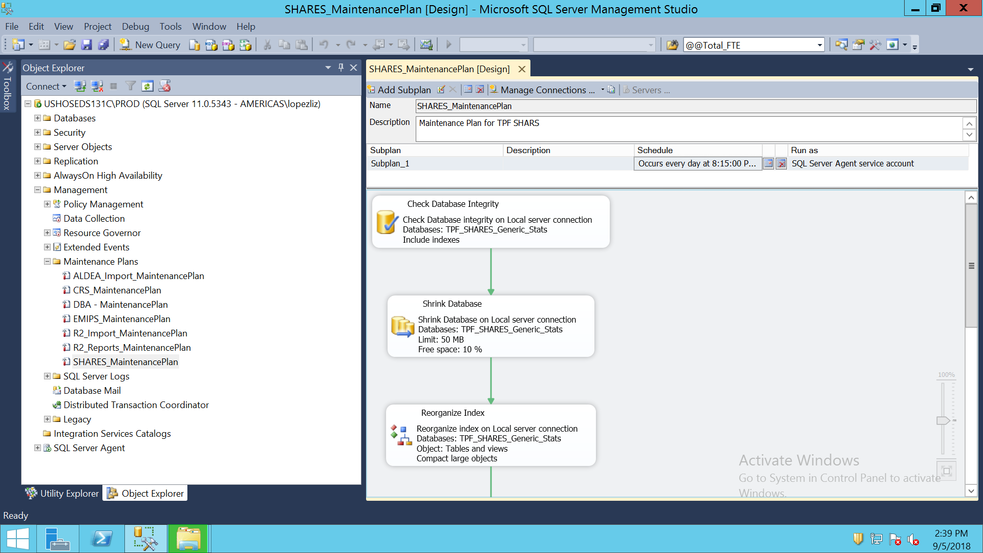

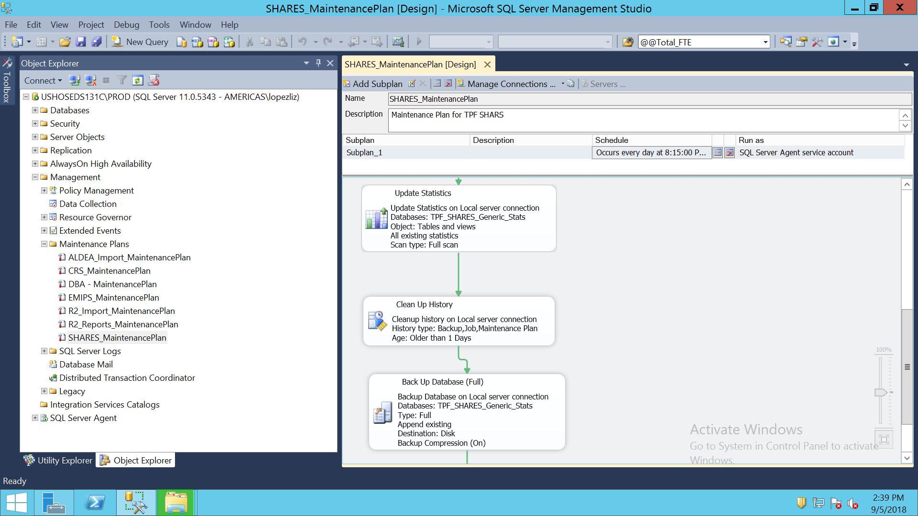

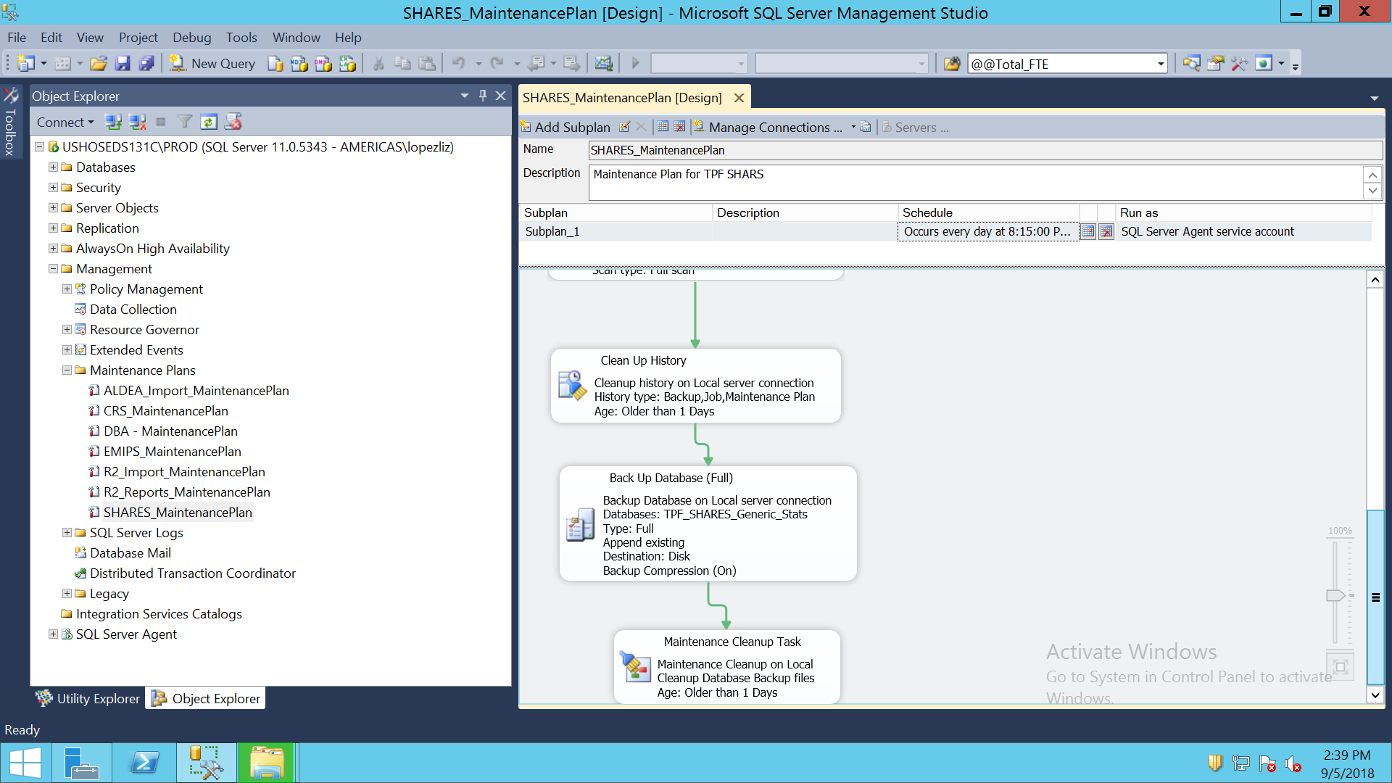

SQL SERVER AGENT

PROXIES

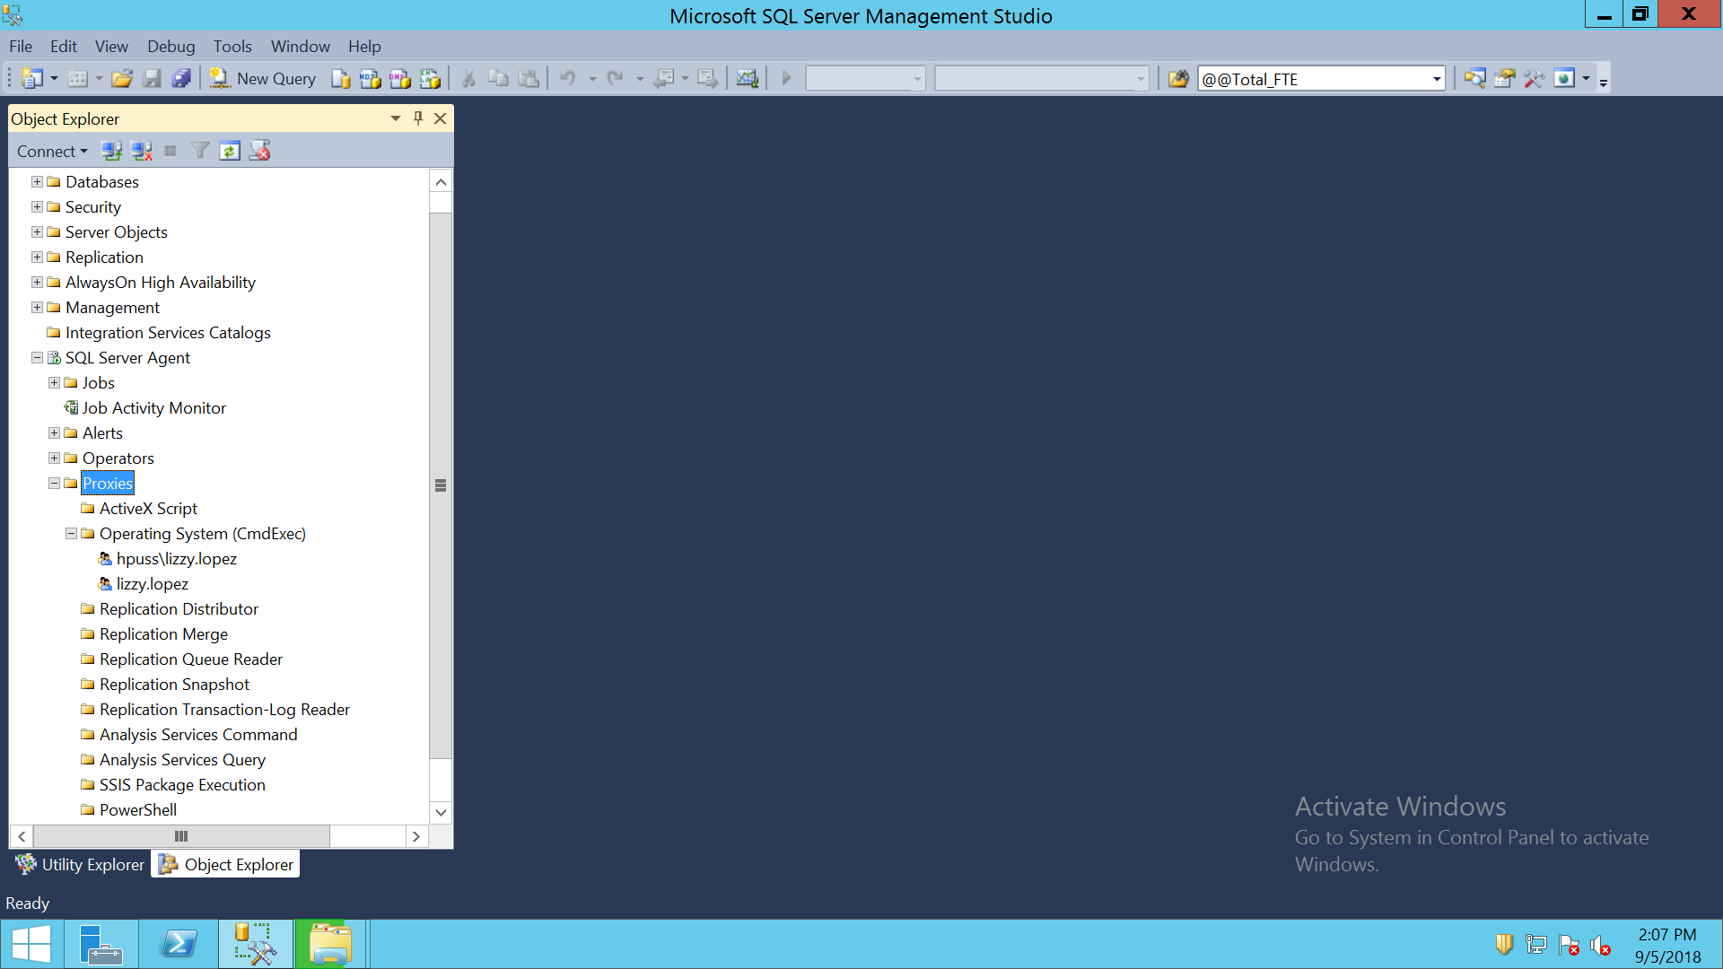

JOBS

